
COMSATS University Islamabad, Sahiwal Campus

SkillSync
A Curated Platform for Skill-Based Learning

A project presented to
COMSATS Institute of Information Technology, Islamabad

In partial fulfilment
of the requirements for the degree of

Bachelor of Science in Software Engineering (2022-2026)

By

Muhammad Bilal Hanif CIIT/SP22-BSE-024/SWL Muhammad Ahmad CIIT/SP22-BSE-022/SWL

Declaration
We hereby declare that this software, neither whole nor as a part, has been copied from any source. It is further declared that we have developed this software and the accompanied report entirely based on our personal efforts. If any part of this project is proved to be copied from any source or found to be a reproduction of some other work. We will stand by the consequences. No Portion of the work presented has been submitted to any application for any other degree or qualification of this or any other university or institute of learning.

Muhammad Ahmad Muhammad Bilal Hanif

CERTIFICATE OF APPROVAL
It is to certify that the final year project of BS (SE) “SkillSync” was developed by Muhammad Bilal Hanif (CIIT/SP22-BSE-024/SWL) and Muhammad Ahmad (CIIT/SP22- BSE-022/SWL) under the supervision of “Ms. Nusra Rehman” that in her opinion, it is fully adequate, in scope and quality for the degree of Bachelor of Science in Computer Sciences.

Supervisor
Ms. Nusra Rehman
Lecturer
Department of Software Engineering COMSATS University Islamabad, Sahiwal Campus

External Examiner

Dr. Zafar Iqbal Roy
Assistant Professor
Head of Department
(Department of Computer Science) COMSATS University Islamabad, Sahiwal Campus

Executive Summary
SkillSync is a modern, web-based educational platform designed to transform Pakistan’s traditional and informal skill-learning system into a structured, secure, and expert-verified digital solution. In many cities, online learning still relies on manual communication, unverified tutorials, and unreliable content workflows, causing delays, misinformation risks, and quality concerns for both students and professional educators. SkillSync addresses these challenges by introducing a centralized learning ecosystem that provides transparent processes, verified experts, secure approval workflows, and streamlined communication.
The platform supports user registration and JWT-based login, enabling students, verified experts, and administrators to access customized dashboards designed for their specific roles. Students can search for skills using category-based filters, view verified listings, submit enrollment requests, and receive updates in real time. Verified experts can create and manage learning tracks, process lesson approvals, and securely communicate with interested students. Each instructor is activated only after successful admin-led interview verification, ensuring authenticity and preventing fraudulent postings.
SkillSync introduces additional features to enhance reliability and user trust, including controlled credential sharing, lesson approval workflows, and verified badges that can only be awarded after successful course completion. Admins maintain platform oversight by monitoring instructor activity, viewing application logs, managing system integrity, and handling flagged content when necessary.
The system is built using Node.js with Express.js for backend services, React.js with Tailwind CSS for a responsive and user-friendly interface, and PostgreSQL for secure and scalable data storage. Sequelize integration ensures safe database transactions, while secure gateways support role-based authentication and real-time user access. The platform is optimized for mobile and desktop users, offering accessible and intuitive interaction across devices.
By combining modern web technologies, secure instructor verification, role-based workflows, and privacy-preserving discussion mechanics, SkillSync delivers a comprehensive skill management solution tailored to local market needs. It elevates transparency, improves user safety, reduces fraud, and modernizes the entire professional learning experience in Pakistan’s growing digital landscape.

Acknowledgement
All praise is to Almighty Allah, who bestowed upon us a minute portion of His boundless knowledge by which we were able to accomplish this challenging task.
We are greatly indebted to our project supervisor, “Ms. Nusra Rehman”. Without their personal supervision, advice and valuable guidance, completion of this project would have been doubtful. We are deeply indebted to them for their encouragement and continual help during this work.
And we are also thankful to our parents and family who have been a constant source of encouragement for us and brought us the values of honesty & hard work.

Muhammad Ahmad Muhammad Bilal Hanif

Abbreviations

API | Application Programming Interface
CS | Computer Science
SRS | Software Requirement Specification
SDD | Software Design Description
GUI | Graphical User Interface
AG | Agile Model
IDEs | Integrated development environments
UI | User Interface
UX | User Experience
DB | Database
CRUD | Create, Read, Update, Delete
API | Application Programming Interface
CS | Computer Science
SRS | Software Requirements Specification
SDD | Software Design Description
GUI | Graphical User Interface
AG | Agile Model
IDEs | Integrated Development Environments

TABLE OF CONTENTS

- Introduction 11
  - Brief Overview 12
  - Relevance to Course Modules 13
  - Project Background 14
  - Analysis from Literature Review (in the context of the project) 14
  - Methodology and Software Lifecycle for This Project 15
    - Rationale behind Selected Methodology 16
- Problem Definition 18
  - Problem Statement 19
  - Deliverable and Development Requirements 19
    - Deliverables 20
    - Development Requirements 21
  - Current System 22
    - Key Limitations of Existing Systems 22
- Requirement Analysis 25
  - Use Case Diagram 25
  - Use Case Description 27
    - User Registration and Login 27
    - Logout 29
    - Profile Management 30
    - Apply for Instructor Verification 31
    - Manage Instructor Applications 32
    - Browse and Enroll in Learning Tracks 33
    - View Learning Track and Lessons 34
    - Track Progress 36
    - Participate in Discussion Forum 37
    - Create and Manage Learning Tracks 38
    - Upload and Manage Lessons 39
    - Manage Lesson Submissions 40
    - Manage Content Categories 42
    - Manage User Reports and Monitor Activity 43
  - Functional Requirements 44
    - User Authentication 44
    - Profile Management & Verification 46
    - Student Learning 47
    - Progress Tracking 48
    - Discussion & Interaction 49
    - Instructor Content Management 50
    - Administrative Curation and Management 51
  - Non-Functional Requirements 52
    - Usability 52
    - Performance 53
    - Security 53
    - Portability 54
    - Reliability 54
    - Maintainability 54
    - Scalability 55
- Design and Architecture 57
  - System Architecture 57
  - Process Flow Representation 58
  - Sequence Diagram 59
  - Class Diagrams 60
- Implementation 63
  - Setup of Development Environment 63
    - Frontend Environment 63
    - Backend Environment 63
    - Development Tools and Testing Setup 63
  - Database Design and Implementation 63
    - Database Structure 63
    - Relationships and Data Integrity 64
    - Security and Access Rules 64
  - User Authentication and Authorization 64
    - OTP-Based Login Mechanism 64
    - Role-Based Access Control 64
    - Session Management and Security 64
  - User Interface Development 65
    - Student Interface 65
    - Verified Expert Interface 65
    - Admin Interface 65
  - Learning Track and Enrollment Management 65
    - Track Creation and Verification 65
    - Student Search and Filtering 66
    - Enrollment Workflow 66
  - Instructor Verification System 66
    - Expert Application Processing 66
    - Admin Oversight and Content Validation 66
    - Admin Oversight and Dispute Handling 67
  - Discussion and Interaction Module: 67
    - Forum Participation and Douglas 67
    - Moderation and Expert Response 67
  - Notification and Progress Tracking Module 67
    - System Notification Delivery 67
    - Persistent Learning History and Progress 68
  - Admin Panel and System Management 68
    - Expert and Content Management 68
  - Algorithm 68
  - User Interface 69
    - Authentication Interface Screens 69
    - Admin Interface Screens 70
    - Instructor (Expert) Interface Screens 73
    - Student Interface Screens 75
- Testing and Evaluation 80
  - Manual Testing 80
    - Unit Testing 82
    - Functional Testing 83
    - Integration Testing 84
  - Automated Testing 85
- Conclusion and Future Work 87
  - Conclusion 87
    - Technical Architecture: 87
    - System Architecture Overview: 87
  - Future Work 87
    - AI-Powered Learning Recommendations 88
    - Dynamic Content and Revenue Models 88
    - Integrated Mentorship and Maintenance 88
    - Enhanced Interaction with Voice & File Sharing 88
    - Advanced Admin Analytics 88
    - Mobile Application Version 88
    - KYC and Credential Automation 88
    - Smart Geo-Location and Localized Skills 88
    - Augmented Reality (AR) Skill Previews 88
- References 89

LIST OF FIGURES
Figure 3.1- 1: Use Case Diagram 27
Figure 4.1-2: Architecture Diagram 58
Figure 4.2-3:Process Flow Diagram 60
Figure 4.3 - 4: Property Rent Payment and Reviews 62
Figure 4.4 - 5: Class Diagram 64
Figure 5.11.1 - 6: SignUp Page 70
Figure 5.11.1 - 7: Login Screen 71
Figure 5.11.2 - 8: Admin Overview Dashboar 72
Figure 5.11.2 - 9: Admin Instructor Management & Approvals 73
Figure 5.11.2 - 10: Admin Student Management Screen 75
Figure 5.11.2 - 11: Admin Course Control Panel 75
Figure 5.11.2 - 12: Admin Student Reports & Moderation Screens 76
Figure5.11.3 - 13: Instructor Dashboard & Course Management 77
Figure 5.11.3 - 14: Instructor Communication & Messaging Hub 78
Figure 5.11.4 - 15: SkillSync Landing Page & Learning Path 79
Figure 5.11.4 - 16: Student Certificate History & Progress 80
Figure 5.11.4 - 17: Verified Certificate Preview Screen 81

LIST OF TABLES
Table 3.2.1-1: Use Case - User Registration and Login 28
Table 3.2.2-2: Use Case - Logout 29
Table 3.2.3 - 3: Use Case - Profile Management 29
Table 3.2.4 - 4: Apply for Instructor Verification 30
Table 3.2.5 – 5: Use Case - Manage Instructor Application 31
Table3.2. 6 – 6: Use Case - Browse and Enroll in Learning Tracks 31
Table 3.2.7 – 7: Use Case - View Learning Track and Lesson 32
Table 3.2.8 – 8: Use Case - Track Progress 33
Table 3.2.9 – 9: Use Case - Participate in Discussion Form 33
Table 3.2.10 – 10: Use Case - Create and Manage Learning Tracks 34
Table 3.2.11 – 11: Use Case - Upload and Manage Lessons 35
Table 3.2.12 – 12: Use Case - Manage Lesson Submission 36
Table 3.2.13 – 13: Use Case - Manage Content Categories 37
Table 3.214 – 14: Use Case - Manage User Reports and Monitor Activity 37
Table 3.3.1-15: Functional Requirement - User Authentication 38
Table 3.3.2-16: Functional Requirement - Profile Management & Verification 39
Table 3.3.3-17: Functional Requirements - Stident Learning 40
Table 3.3.4-18: Functional Requirement - Progress Tracking 41
Table 3.3.5- 19: Functional Requirement - Discussion & Interaction 42
Table 3.3.6-20: Functional Requirement - Instructor Content Management 42
Table 3.3.7 - 21: Functional Requirement - Administrative Curation and Management 43
Table 6.1 - 22: Manual Testing 80
Table 6.1.1 - 23: Unit Testing 83
Table 6.1.2 - 24: Functional Testing 84
Table 6.1.3 -25: Integration Testing 85

10

Chapter 1 Introduction

Introduction
In today’s technology-driven society, the way people search for professional skills and interact with verified experts has changed significantly. Traditional methods such as local workshops, unverified video links, and verbal references have become inefficient and unreliable in a rapidly digitalizing world. Modern users now prefer to make learning decisions based on verified online information, trustworthy instructors, and transparent communication. However, the current e- learning ecosystem still struggles with challenges like fake expertise, unmoderated content, and privacy risks between students and teachers. These issues reduce user confidence and create unnecessary delays in finding suitable skill-based options.
While general video platforms and social media groups provide space for posting educational clips, they largely rely on unstructured information and manual communication. These platforms lack proper verification mechanisms, resulting in misleading details, outdated lessons, or fraudulent practices. Moreover, students are often required to navigate through low-quality tutorials early in the process, exposing them to time waste and academic concerns. The absence of structured workflows makes it difficult to assess instructor credibility, track learning progress, or validate expertise securely. Overall, current systems fail to support a safe and organized learning experience for both students and experts.
With digital adoption increasing rapidly across Pakistan, there is a clear demand for modern, reliable, and easy-to-use skill platforms. People now expect real-time information, streamlined enrollment processes, and platforms that prioritize transparency and trust. It is evident that the modern user seeks more than basic tutorial ads; they want features such as secure authentication, verified experts, privacy-focused interaction, and simplified education-related workflows. This shift highlights the need for a specialized platform that combines convenience, security, and structure while addressing the shortcomings of existing learning systems.
To address these limitations, SkillSync emerges as a transformative solution. It is a web-based skill management platform designed to bridge the communication gap between students and verified experts through a structured and semi-contactless digital process. By allowing users to browse category-based listings, submit enrollment requests, and communicate only after approval, SkillSync ensures privacy, authenticity, and trust throughout the learning journey. Its integrated admin-led vetting system verifies instructor applications automatically, ensuring that only legitimate and approved content becomes visible to the public.
What makes SkillSync stand out is its fully role-based ecosystem. The platform goes beyond simple video listings by offering secure JWT-based login, automated lesson activation, enrollment

approval workflows, and verified course badges that build credibility. For verified experts, SkillSync provides tools to manage tracks, respond to student queries, and monitor system activity, while admins oversee platform integrity through application logs, approval checks, and moderation features.
SkillSync creates a win-win system where students gain access to trustworthy education with protected personal information, and experts benefit from increased visibility, reduced fraud, and simplified management. In doing so, the platform not only modernizes the learning experience but also supports the educational market in adapting to evolving digital expectations.

Brief Overview
SkillSync is a modern, web-based skill management platform developed using React.js for the front end and Node.js with PostgreSQL as the backend service. It redefines the vocational learning process by offering secure course management, category-based search, and structured enrollment workflows. The platform blends automation with user-centric functionality, creating a seamless and transparent experience for students, verified experts, and administrators.
From the student perspective, SkillSync provides streamlined navigation across essential features:
- Category-Based Skill Search: Students can explore learning tracks using filters such as category and skill level to find suitable courses quickly.
- Enrollment Requests: Users can express interest without revealing personal contact details, ensuring privacy during the initial interaction.
- Verified Badges System: After completing a course, students receive verified badges and track history to help validate their learning journey.
- Secure JWT Authentication: Users access the platform through role-based JWT login, eliminating password concerns and enhancing security.
- Lesson Details & Communication: Students can view complete track information and engage in discussion forums only after enrolling.
On the business side, verified experts access a dedicated dashboard equipped with tools to:
- Create and Manage Learning Tracks: Experts can add lesson details, update curriculum order, and maintain accurate educational information.
- Admin-Based Listing Activation: Lessons are published only after successful admin approval, ensuring authenticity and preventing fraudulent posts.
- Review Enrollment Progress: Experts can monitor student progress and respond to questions, triggering controlled support upon enrollment.

- Manage Student Interactions: Experts can monitor incoming queries, respond to discussion posts, and keep track of learning activities.
Admins maintain system reliability through real-time monitoring, instructor oversight, and interaction tracking, ensuring platform integrity and fair usage for all users.

Relevance to Course Modules
SkillSync’s development is strongly grounded in the concepts and practical skills acquired throughout the Bachelor of Science in Software Engineering program. The project integrates multiple theoretical and technical modules from the curriculum. Below is a detailed breakdown of how various course modules contributed to the system:
- Software Engineering Concepts: Applied extensively for requirement gathering, defining use cases, modeling user interactions, sprint planning, and risk mitigation. Agile development practices, particularly Scrum, were implemented to support iterative progress and deliver incremental features.
- Software Design Methodologies: Used in designing the system’s multi-layered architecture, including the front end (React.js), backend APIs (Node.js & Express.js), and the integration layer for database services. Design patterns and UML diagrams guided modular and scalable development.
- Database Systems: PostgreSQL, combined with Sequelize ORM, was utilized for efficient data management. Tables were structured for users, videos, bookings, progress, and badges. Indexing and schema design principles enhanced query performance.
- Human-Computer Interaction (HCI): HCI principles shaped the intuitive and responsive interface of SkillSync. Prototypes were designed to ensure smooth navigation, clear visual hierarchy, and mobile-friendly layouts.
- Web Application Development: Core implementation relied on React.js for responsive UI and Node.js with Express.js for API creation. RESTful architecture and JSON-based communication were applied to structure data exchange.
- Cloud Computing & Deployment: SkillSync uses cloud-based hosting platforms (such as Render or Vercel) for deployment and CI/CD automation. Concepts like environment variables and storage decoupling (S3) ensured efficient deployment cycles.
- Cyber Security: Techniques were applied through JWT-based authentication, bcrypt hashing, role-based access control, and input validation. These measures protected sensitive information from common vulnerabilities.
- Software Quality Assurance (SQA): Testing strategies such as unit testing and integration

testing were used to ensure system correctness. Test cases were derived from functional requirements to improve reliability.

Project Background
The idea behind SkillSync originated from a study of the shortcomings in the current online learning ecosystem. Despite the digital transformation in education, the skill market continues to rely heavily on unvetted and unregulated processes. Traditional methods such as random social media posts and verbal referrals remain dominant, leading to communication delays and misinformation. Existing platforms like YouTube offer general learning, but they do not align with modern expectations for verified, secure processes.
A significant shift that shaped SkillSync was the evolution of user behavior toward digital-first learning. People want quick access to authentic, verified information. In the education domain, users increasingly demand clear course details and proof of legitimacy before engaging with instructors. This rising need for reliability inspired building SkillSync where every instructor becomes verified through admin interviews, ensuring authenticity.
Another insight was the lack of controlled communication between students and experts. Traditional channels often expose personal details too early, resulting in privacy violations. SkillSync introduces a structured system where enrollment and communication follow defined steps, ensuring both parties remain protected.
The project was also motivated by challenges of fake expertise and misleading content. Many students fall victim to incomplete tutorials or outdated info. SkillSync integrates admin-based activation and JWT-secured authentication, ensuring every lesson originates from verified users. This approach builds trust within the learning community.
Furthermore, SkillSync incorporates a verified progress system, allowing students to share genuine feedback only after completing a course. This ensures credibility and prevents fabricated ratings. For experts, these insights provide actionable data for service improvement.
Ultimately, SkillSync was developed as a secure, interconnected learning system. It aims to modernize the experience by combining privacy-focused workflows and real-time digital tools. By leveraging structured processes and automated verification, SkillSync redefines how skills are discovered and managed in a digital landscape.

Analysis from Literature Review (in the context of the project)
The development of SkillSync is informed by research into existing e-learning platforms. The literature review provided theoretical grounding and highlighted gaps SkillSync aims to address.
- Trust Deficit in Unregulated Platforms: Studies highlight concerns related to misleading

or fraudulent online content. SkillSync responds by integrating admin-based activation and JWT login, ensuring only verified instructors become visible.
- Growing Demand for Online Solutions: Digital skill search has grown significantly, with users prioritizing convenience and transparency. SkillSync aligns by providing a structured platform where students explore category-based listings securely.
- Low User Trust and Privacy: Traditional interactions often suffer from privacy concerns. Research indicates students hesitate to share contact details due to risks of misuse. SkillSync addresses this with a semi-contactless model where communication is visible only after enrollment.
- Lack of Standardized Workflows: Many platforms lack structured workflows for verification and follow-up. SkillSync introduces standardized enrollment pipelines, automated activation, and admin approval mechanisms that ensure accountability.
- Technology Trends: Literature supports cloud-based platforms for scalability. Technologies like React.js and Node.js are recognized for reliability. SkillSync adopts these trends using a PostgreSQL architecture and secure verification pipelines.
- Two-Way Interaction and Feedback: Verified reviews significantly influence decision- making. SkillSync implements a post-learning badge and forum system, tying interaction to actual history. This ensures accuracy and builds community trust.

Methodology and Software Lifecycle for This Project
To ensure structured and user-centered development, the Agile Scrum methodology was selected. This allowed for iterative cycles and continuous refinement of the SkillSync platform.
- Product Backlog Creation: Requirements such as JWT-based login, track creation, and admin approval were documented as user stories. These were prioritized forming the product backlog.
- Sprint Planning: Development was carried out through iterative sprints. Sprints focused on specific features like instructor dashboards, video pipelines, and admin management.
- Daily Coordination: Team coordination improved synchronization between backend, frontend, and database tasks, ensuring alignment.
- Sprint Review: At the end of cycles, modules such as category filters or JWT login were reviewed. Stakeholder feedback shaped the next cycle.
- Incremental Builds: SkillSync followed an incremental build strategy, releasing functional modules regularly. Components like enrollment logic were tested independently before integration into the main system.

Rationale behind Selected Methodology
Agile Scrum was chosen for its flexibility and responsiveness to change. Traditional models like Waterfall were considered too rigid for a platform with evolving requirements.
      - Limitations of Traditional Models: Waterfall follows a rigid linear progression, making it unsuitable for accommodating changing feedback. SkillSync needed to adapt rapidly to feedback on workflows and UI usability.
      - Modular Approach: Scrum allowed focusing on discrete modules such as student features, expert controls, and admin tools. Tasks like implementing approvals or JWT login could be developed independently.
      - Early Validation: The iterative nature supported early releases of functional builds. Modules like the login system were tested early, reducing the risk of late changes.
      - Support for Multi-Role Functionality: SkillSync required separate features for three actors. Scrum made it easier to divide development into segments, ensuring organized and manageable progress.
      - Risk Management and Quality: Agile supports early testing, essential for high-risk components like video streaming and secure authentication. Regular testing minimized bugs and maintained system stability.

Chapter 2 Problem Definition

Problem Definition
The skill development and professional training industry is undergoing rapid transformation, influenced by the rise of digital platforms, widening internet access, and increasing consumer demand for transparency and security. In today’s connected environment, students no longer rely solely on verbal recommendations, unverified video links, or scattered social media posts. Instead, they prefer accurate, updated, and trustworthy online information before making learning decisions. Although online learning content exists on platforms like YouTube and various social media groups, the material is often unregulated, outdated, and lacks mechanisms to ensure authenticity or protect user privacy.
Despite the availability of multiple channels for skill exploration, most existing platforms fail to provide a holistic, secure, and structured experience that matches modern user expectations. They typically operate as general repositories with minimal verification, no structured enrollment workflows, and limited tools for experts to manage interactions. The absence of controlled communication leads to privacy issues, as students and instructors often interact through irregulated channels. Moreover, educational scams, fake expertise, and informal instruction create an unreliable environment where users struggle to trust the information presented.
There is a significant need for a unified, secure, and interactive platform that not only streamlines the skill discovery process but also ensures that instructors are legitimate and content is protected. Features such as verified expert listings, admin-backed activation, JWT authentication, controlled contact sharing, and structured enrollment requests can create a safer and more transparent learning ecosystem. Such an approach transforms the learning process from a risky, unregulated journey into a guided, trustworthy, and well-managed experience.
SkillSync aims to address these challenges by offering a full-featured skill management system that integrates secure authentication, automated instructor verification through admin interviews, category-based skill search, a semi-contactless enrollment workflow, and verified post-learning reviews. The platform empowers students with reliable data and privacy control, while providing verified experts with tools for track management, enrollment approval, and communication tracking. Centralized admin oversight ensures content quality, system security, and fair platform usage.
By embracing structured workflows, trust-building mechanisms, and transparent digital interactions, SkillSync solves key limitations of current learning solutions and establishes a next- generation platform for skill discovery, verification, and management.

Problem Statement
In today’s technology-driven society, the way individuals search for professional skills and interact with subject matter experts has changed dramatically. While traditional methods such as physical workshops, printed ads, and scattered social media posts have long served as primary sources of educational information, they no longer align with the expectations of modern users. These outdated methods often lack credibility, transparency, and accurate details, leaving potential students with incomplete, misleading, or unverifiable impressions of available training.
Furthermore, many existing learning platforms and social media groups are plagued by fraudulent expertise, unauthorized instructors, and outdated information. Fake credentials, misleading course descriptions, and unverified instructional quality are common issues that diminish user trust and undermine the reliability of such platforms. Although some websites allow video uploads or descriptions, they still fail to provide verification mechanisms that ensure the legitimacy of instructors or the authenticity of lessons.
In addition, current learning platforms are fragmented and offer limited support for structured communication. Students must rely on unregulated channels to contact instructors, often exposing their personal contact information prematurely. Experts, on the other hand, lack tools to manage student queries, approve enrollment requests, or track track performance in a centralized and secure manner. There is no unified system that provides verified experts, controlled contact sharing, enrollment workflows, and post-learning feedback all within a trusted digital ecosystem.
SkillSync directly addresses this gap by introducing a comprehensive skill management platform focused on authenticity, security, and structured interaction. It provides students with access to verified learning tracks supported by admin-based activation and JWT-secured login. At the same time, it enables verified experts to manage learning tracks, approve enrollment requests, and communicate securely with potential students. The platform fosters a more transparent, trustworthy, and organized learning ecosystem by combining verification workflows, privacy protection, and centralized oversight.

Deliverable and Development Requirements
The SkillSync platform aims to deliver a secure, web-based skill management system that modernizes Pakistan’s traditional educational workflows. The system includes complete digital ecosystems for students, verified experts, and administrators to ensure transparency, reliability, and efficient communication throughout the learning lifecycle.

Deliverables
The SkillSync student web application provides a secure and user-friendly experience through JWT-based authentication using email and password verification. Students can easily search for learning tracks using advanced category-based filters and organized skill paths. The system allows students to submit enrollment requests without revealing their personal contact information, ensuring privacy and safety. Detailed track information, along with expert details (shared only after enrollment), and real-time progress status are displayed to assist in decision-making. Additionally, students can earn verified badges and track their progress after successfully completing a lesson, helping maintain transparency and trust within the platform.
The web application for verified experts allows instructors to register and securely authenticate using JWT verification, after which they can manage their personalized dashboards. Experts can create, edit, and manage learning tracks by adding video lessons, descriptions, and category information. A formal verification module is integrated for processing instructor applications, ensuring only admin-approved experts appear publicly. A dedicated enrollment management module enables experts to review student progress and respond to queries, with student interaction details shared only after enrollment to maintain privacy. Additionally, experts can view incoming discussion posts and the complete history associated with their tracks.
The admin dashboard provides a centralized interface for system administrators to manage learning tracks, user accounts, and verification activities. It includes real-time reports showing active experts, lesson submissions, flagged content, and user issues. Administrators can access and monitor expert application logs to conduct interviews and block fraudulent instructors when necessary. The platform also includes built-in tools to assist admins in resolving conflicts between students and experts, ensuring smooth platform operations.
SkillSync features a secure enrollment and review system that ensures student privacy and structured approval workflows. Students can submit requests, which follow a defined status cycle including Pending, Approved, and Completed. Only verified students who have engaged with a track can participate in discussion forums. All uploaded content undergoes validation by an admin before being published, maintaining authenticity, reliability, and transparency across the platform. The instructor verification module manages all role-related applications using secure administrative interview workflows. Once an application is successfully processed and approved through the admin panel, the related instructor profile is automatically activated, enabling them to upload content. The system also maintains detailed status logs, providing a complete audit trail for administrators and enhancing operational transparency.

The platform includes a real-time notification system that alerts users about enrollment status, lesson approvals, new discussion posts, and admin updates. Notifications are delivered through in- app alerts and email, ensuring users receive timely updates regardless of their activity. Event-based triggers handle these notifications efficiently, providing fast and reliable communication for all user roles.
The JWT authentication system implements secure, role-based login for all users, enhancing the platform’s safety and convenience. Role-based access control (RBAC) ensures that students, experts, and administrators access only the features relevant to their role. This structured access management maintains system integrity and prevents unauthorized use of sensitive functionalities.

Development Requirements
The development of the SkillSync platform requires a modern, scalable, and secure technology stack that supports web-based interaction among students, experts, and administrators. The system is designed using industry-standard tools and frameworks to ensure seamless integration between the frontend, backend, and database components. These development requirements define the technological foundation necessary to implement all core features, including JWT-based authentication, track management, admin oversight, and enrollment workflows.
The SkillSync platform is built using a modern and scalable technology stack designed for high performance and reliability. The frontend web application for students, experts, and administrators is developed using React.js with Vite, ensuring a responsive and dynamic user experience. The backend is powered by Node.js with Express.js, which handles JWT authentication, learning track management, enrollment workflows, and content processing.
PostgreSQL serves as the primary relational database, offering a scalable solution for storing user accounts, educational records, progress, and track data. Database operations are managed via the Sequelize ORM. Video lessons and related media are stored using local storage during development with a transition to AWS S3 for production.
The admin dashboard, built using React.js and Node.js, allows administrators to manage users, experts, content approvals, and system analytics by communicating directly with backend APIs. The system uses a modular architecture, separating frontend, backend, and database components to ensure maintainability and scalability. Security is enforced through role-based access control (RBAC), encrypted data transmission, and backend middleware that protects API routes and limits privileged operations.
The React.js UI is designed to provide a smooth, modern, and responsive experience for all user roles. Interface components are developed using Tailwind CSS for efficient management of system

layout and visual hierarchy. Instructors can add and manage tracks only after completing the admin verification workflow. Admin users can monitor flagged content or suspicious activity for compliance.
The web application is deployed on cloud servers such as Vercel for the frontend and Render for the backend for optimal performance. The database runs on managed PostgreSQL hosting to ensure reliability. Real-time sync between lessons, progress, and dashboard data is maintained through RESTful API communication. GitHub is used for version control, team coordination, and continuous code integration.
The system undergoes comprehensive testing to ensure reliability and accuracy. Unit Testing is performed using Jest to verify the correct functioning of backend services and core logic. Integration Testing focuses on validating seamless interaction between key modules such as JWT authentication, progress tracking, and database operations. Finally, manual testing is conducted to confirm that the platform meets all functional requirements before deployment.

Current System
At present, most skill-learning processes in Pakistan are handled through traditional, manual, and informal methods. Students rely heavily on unvetted instructors, unorganized YouTube playlists, or word-of-mouth to find learning options. Subject matter experts also depend on outdated channels for advertising, managing student queries, and handling content distribution. These systems are fragmented and inconsistent, each addressing only a small part of the learning experience, such as video hosting, communication, or progress tracking.

Key Limitations of Existing Systems
The major limitations of current learning systems include manual and unverified instructor registration where anyone can post tutorials without quality control. Most learning transactions are handled through informal communication methods, causing delays and a lack of transparency for both students and instructors. There is no unified, reliable online platform where students can explore verified learning tracks with structured beginner-to-advanced levels.
Existing platforms often contain unorganized content, missing structure, or incomplete instructions, making decision-making difficult for learners. Current systems do not provide a structured method for students to submit enrollment requests or for instructors to track student progress in real-time. This leads to poor coordination and lost learning opportunities.
Property listings in existing systems often lack verification, resulting in misleading or low-quality advertisements. Instructors and students frequently rely on third-party messaging apps, which do not provide organized tracking of questions or learning statuses. There is no standardized platform

to manage these specialized educational communication channels.
Most platforms do not provide built-in administrative verification for instructor credentials or lesson quality. Experts lack dedicated dashboards where they can track student engagement, manage tracks, or view analytics about learning interactions. Current portals do not provide verified reviews for instructors, creating uncertainty for new learners and offering no accountability mechanism.
The fragmented student journey often requires switching between multiple platforms to search for skills, communicate with experts, and track progress. Finally, current systems lack structured digital tools to support day-to-day educational management and modern personalization.

24

Chapter 3 Requirement Analysis

Requirement Analysis
The system requirements for SkillSync include the registration of students and verified experts, secure JWT-based authentication, learning track management, admin-led expert verification, enrollment request submissions, discussion forum functionalities, and administrative monitoring tools. Additionally, SkillSync enables students to search for skills using advanced category filters, explore verified lessons, and interact with experts through a structured and secure workflow. Verified experts can manage their tracks, respond to student queries, and view progress data, while administrators oversee verification processes, user activity, and platform content moderation.
We will employ the Use-Case technique as the primary requirement analysis method, which effectively describes the interactions between users (referred to as actors) and the system to accomplish specific goals. Use cases help identify and organize the functional requirements of the SkillSync platform, ensuring a clear understanding of how students, experts, and administrators interact with the system. This approach ensures all user roles are clearly supported, and system functionalities remain aligned with educational workflows and project objectives.

Use Case Diagram
The Use Case Diagram illustrates the core functionalities of the SkillSync system and the interactions of various actors with the platform. The primary actors include Guest, Student, Verified Expert, and Admin. Guests have limited access, allowing them only to browse publicly available skill categories. Registered students can interact more extensively with the system by performing actions such as registration, JWT login, searching for learning tracks using detailed filters, viewing lesson details, submitting enrollment requests, tracking learning progress, and participating in discussion forums.
Verified experts have extended functionalities within the system. They can register for verification, authenticate through JWT, manage their profile, add or edit learning tracks, upload video lessons, and handle student interactions by responding to forum queries. Experts also have access to dashboards displaying track performance and student progress trends.
The admin oversees the entire platform’s operations with capabilities to monitor learning tracks, verify expert applications through interviews, manage flagged content, and enforce platform quality. Administrators ensure that instructors are legitimate, content is high-quality, and the platform operates securely and efficiently.
Moreover, the system promotes structured engagement between students and experts through a secure, trackable enrollment workflow, improving transparency and trust in online education. The integrated discussion system ensures accountability and helps learners clear doubts quickly. The

admin-led verification mechanism strengthens the reliability of educational material by ensuring only approved experts and lessons reach the public interface.

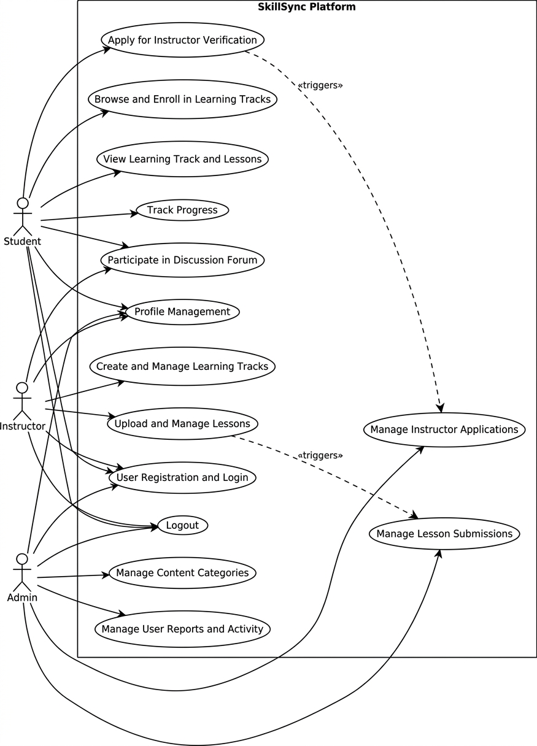

Figure 3.1- 1: Use Case Diagram

Use Case Description
The tables below present detailed use case templates illustrating how system interactions are structured in SkillSync. A use case defines a specific system functionality by describing how students, verified experts, and administrators interact with the platform to complete education- related workflows such as login, track management, skill search, enrollment approvals, and content moderation.
Each case outlines key elements such as actors involved, triggering actions, normal flows, and system responses. These use cases are designed to ensure secure and quality-focused interactions while maintaining clarity in operational behavior across roles. For instance, users begin by logging into the platform through JWT-based authentication, which ensures secure and role-specific access. Verified experts can create learning tracks, after which the lessons are submitted to the admin queue. Upon successful admin approval, the system activates the lesson for student viewing.
Students can search for skills using smart filters based on category and level. Once a relevant track is found, they can enroll and begin watching lessons. Experts can monitor these enrollments; students are allowed to post in forums to improve platform interactivity and trust. Each use case includes both typical user actions and potential exceptions such as invalid inputs or content load errors. These detailed paths ensure robustness and fault-tolerance across the platform.
The admin role in SkillSync is designed to provide governance and maintain high educational standards. Admins are responsible for manually verifying expert applications and reviewing uploaded lessons for quality. This case design ensures a balance between automation and human curation, improving both reliability and student satisfaction. Overall, the SkillSync system’s use cases are modeled to deliver a streamlined, secure, and role-sensitive learning experience.

– 1 User Registration and Login
Table 3.2.1-1: Use Case - User Registration and Login
Field | Description
Use Case ID | UC-01
Use Case Name | User Registration and Login
Actors | Student, Instructor, Admin (Unauthenticated User)
Description | Allows a new user to create an account or an existing user to log in. Manages authentication for all system roles.
Trigger | User navigates to the system's entry page and selects "Login" or "Register".
Preconditions | System is online. User has a valid email address.
Postconditions | 1. (Registration) A new user account is created with the Student role. 2. (Login) The user is authenticated, and a secure session is established. The user is redirected to their respective dashboard based on their role.
Normal Flow | 1. User selects "Login" or "Register". 2. For Register: User provides name, email, and password. System validates data, creates a new Student account, and logs the user in. 3. For Login: User provides email and password. System validates credentials. 4. System verifies the user's role (Student, Instructor, Admin). 5. System redirects the user to the appropriate dashboard.
Alternative Flows | AF-01.1 (Forgot Password): User selects "Forgot Password". System provides a mechanism to reset the password via email.
Exceptions | EX-01.1 (Invalid Credentials): System displays an error message. EX-01.2 (Email in Use): During registration, system displays an error if the email is already registered.
Business Rules | 1. All users register as Students by default. 2. Passwords must be securely hashed and stored.  3. "secure role-based access control" must be enforced.
Assumptions | User has a stable internet connection.

-2 Logout
Table 3.2.2-2: Use Case - Logout
Field | Description
Use Case ID | UC-02
Use Case Name | Logout
Actors | Student, Instructor, Admin
Trigger | User clicks the "Logout" button.
Preconditions | User is authenticated and has an active session.
Postconditions | User's session is terminated. User is redirected to the public home page or login screen.
Normal Flow | 1. User clicks "Logout". 2. System invalidates the user's authentication token/session. 3. System redirects the user to the login page.
Alternative Flows | AF-02.1 (Session Timeout): System automatically logs the user out after a period of inactivity.
Exceptions | EX-02.1 (Session Error): System fails to invalidate the session; user is forcibly redirected to the login page.
Business Rules | All session data must be securely cleared upon logout.
Assumptions | None.

Profile Management
Table 3.2.3 - 3: Use Case - Profile Management
Field | Description
Use Case ID | UC-03
Use Case Name | Profile Management
Actors | Student, Instructor, Admin
Description | Allows authenticated users to view and update their personal profile information (e.g., name, password, profile picture).
Trigger | User navigates to their "Profile" or "Account Settings" page.
Preconditions | User is logged in (UC-01).
Postconditions | User's profile information is updated in the database.
Normal Flow | 1. User accesses their profile page. 2. User modifies their information and clicks "Save". 3. System validates the input (e.g., password complexity). 4. System updates the user's record.  5. System displays a "Profile Updated" success message.
Alternative Flows | AF-03.1 (Change Password): User must provide their current password to set a new one.
Exceptions | EX-03.1 (Validation Error): System rejects invalid input and displays an error (e.g., "Passwords do not match").
Business Rules | Changing an email address may require re- verification.
Assumptions | User provides valid information.

Apply for Instructor Verification
Table 3.2.4 - 4: Apply for Instructor Verification
Field | Description
Use Case ID | UC-04
Use Case Name | Apply for Instructor Verification
Actors | Student
Description | Allows a user (with the Student role) to submit an application to become a verified Instructor.
Trigger | User navigates to their profile and selects "Become an Instructor".
Preconditions | User is logged in as a Student (UC-01). User has not already applied or been approved.
Postconditions | An "Instructor Application" is created with a "Pending" status and is visible to the Admin.
Normal Flow | 1. User accesses the "Become an Instructor" form. 2. User fills out required information (e.g., qualifications, experience, links to portfolio). 3. User submits the application. 4. System creates a pending application record. 5. System displays a "Application Submitted" success message.
Alternative Flows | None.
Exceptions | EX-04.1 (Submission Error): System fails to save the application and displays an error.
Business Rules | This is the only pathway to becoming an Instructor.
Assumptions | The application form gathers sufficient information for an Admin to make a decision.

Manage Instructor Applications
Table 3.2.5 – 5: Use Case - Manage Instructor Application
Field | Description
Use Case ID | UC-05
Use Case Name | Manage Instructor Applications
Actors | Admin
Description | Allows the Admin to "verif[y] instructors" by reviewing, approving, or rejecting pending applications.
Trigger | Admin accesses the "Instructor Applications" section of the admin dashboard.
Preconditions | Admin is logged in (UC-01). There are pending applications (from UC-04).
Postconditions | 1. (On Approve) The user's role is changed from Student to Instructor. 2. The application's status is updated (Approved/Rejected). 3. The user is notified of the decision.
Normal Flow | 1. Admin accesses the list of pending instructor applications. 2. Admin selects an application to review. 3. System displays the applicant's submitted details. 4. Admin clicks "Approve" or "Reject". 5. System updates the user's role in the database (if approved). 6. System updates the application status.
Alternative Flows | None.
Exceptions | EX-05.1 (Role Update Error): System fails to update the user's role and displays an error to the Admin.
Business Rules | Only Admins can approve instructors. This step is mandatory before a user can access Instructor privileges.
Assumptions | Admin performs any necessary external validation of credentials.

Browse and Enroll in Learning Tracks
Table3.2. 6 – 6: Use Case - Browse and Enroll in Learning Tracks
Field | Description
Use Case ID | UC-06
Use Case Name | Browse and Enroll in Learning Tracks
Actors | Student
Description | Allows Students to "explore available skills, and enroll in learning tracks according to their interests".
Trigger | Student accesses the "Explore Skills" or "Course Catalog" page.
Preconditions | Student is logged in (UC-01).
Postconditions | The Student is successfully enrolled in the selected track. The track is added to their personal dashboard.
Normal Flow | 1. Student navigates to the skill exploration page. 2. System displays a list of available learning tracks, filterable by category. 3. Student selects a track to view its details (description, instructor, lessons). 4. Student clicks "Enroll". 5. System links the track to the Student's account.  6. System redirects the Student to their dashboard (UC-08) or the track's main page (UC-07).
Alternative Flows | AF-06.1 (Already Enrolled): If the Student is already enrolled, the "Enroll" button is replaced with "View Track".
Exceptions | EX-06.1 (Enrollment Error): System fails to enroll the Student and displays an error.
Business Rules | All verified, published tracks are available for enrollment.
Assumptions | The platform provides a "User-Friendly Interface" for browsing.

View Learning Track and Lessons
Table 3.2.7 – 7: Use Case - View Learning Track and Lesson
Field | Description
Use Case ID | UC-07
Use Case Name | View Learning Track and Lessons
Actors | Student
Description | Allows an enrolled Student to access the "structured learning tracks" and view the individual lesson content (e.g., videos, text).
Trigger | Student selects an enrolled track from their personal dashboard (UC-08).
Preconditions | Student is logged in (UC-01) and enrolled in the track (UC-06).
Postconditions | Student consumes the lesson content. Lesson is marked as "Complete" upon finishing.
Normal Flow | 1. Student accesses their dashboard and clicks on an enrolled track. 2. System displays the "structured learning track" with all lessons "organized in a proper order". 3. Student selects a lesson to view. 4. System displays the lesson content (e.g., video player, article). 5. Upon completion (e.g., video ends, "Mark as Complete" is clicked), the system updates the Student's progress.
Alternative Flows | AF-07.1 (Navigate Lessons): Student can navigate between lessons in the track.
Exceptions | EX-07.1 (Content Load Error): System fails to load lesson content (e.g., video) and displays an error.
Business Rules | Only "Approved" lessons (from UC-12) are visible to Students.
Assumptions | "Video lessons need high storage and bandwidth".

Track Progress
Table 3.2.8 – 8: Use Case - Track Progress
Field | Description
Use Case ID | UC-08
Use Case Name | Track Progress
Actors | Student, System
Description | Allows a Student to "track their learning progress through a personal dashboard". The system "keeps track of the student’s learning journey".
Trigger | Student navigates to their personal dashboard.
Preconditions | Student is logged in (UC-01).
Postconditions | Student can visualize their progress and "stay motivated and organized".
Normal Flow | 1. Student accesses their dashboard. 2. System retrieves and displays all enrolled tracks. 3. For each track, the system "shows the number of lessons completed, progress percentage, and pending modules". 4. The progress is automatically updated as the Student completes lessons (from UC-07).
Alternative Flows | None.
Exceptions | EX-08.1 (Data Sync Error): The dashboard fails to load the most recent progress; displays a "syncing" or "error" message.
Business Rules | Progress must be updated in real-time or near- real-time.
Assumptions | Progress data is accurately stored and calculated.

Participate in Discussion Forum
Table 3.2.9 – 9: Use Case - Participate in Discussion Form
Field | Description
Use Case ID | UC-09
Use Case Name | Participate in Discussion Forum
Actors | Student, Instructor
Description | Provides a "discussion and support system" where Students can "ask questions" and Instructors can "respond to student queries".
Trigger | A Student or Instructor accesses the "Discussion" tab within a lesson or learning track.
Preconditions | User is logged in (UC-01). Student must be enrolled (UC-06). Instructor must be verified (UC-05).
Postconditions | A new question or response is posted and visible to other participants.
Normal Flow | 1. (Student) Accesses the discussion forum for a lesson. 2. Posts a question. 3. System saves the question and notifies the track's Instructor. 4. (Instructor) Receives notification or accesses the forum. 5. Posts a response. 6. System saves the response, and the Student is notified.
Alternative Flows | AF-09.1 (Student Responds): Other enrolled Students can also view and respond to questions.
Exceptions | EX-09.1 (Post Fails): System fails to save the post due to a connection error and prompts the user to retry.
Business Rules | Instructors are the primary responders. All discussion must be filterable by the Admin for moderation (UC-14).
Assumptions | This direct communication "make[s] the learning process more engaging and effective".

Create and Manage Learning Tracks
Table 3.2.10 – 10: Use Case - Create and Manage Learning Tracks
Field | Description
Use Case ID | UC-10
Use Case Name | Create and Manage Learning Tracks
Actors | Instructor
Description | Allows a verified Instructor to "create structured learning tracks" and "manage course content".
Trigger | Instructor accesses their "Instructor Dashboard" and selects "Create New Track".
Preconditions | User is logged in (UC-01) and has an Instructor role (approved in UC-05).
Postconditions | A new learning track container is created, or an existing one is updated (e.g., title, description, lesson order).
Normal Flow | 1. Instructor navigates to their dashboard. 2. Instructor selects "Create Track". 3. Instructor enters track details (title, description, category).  4. System saves the new track. 5. Instructor can then add/organize lessons (UC-11) within this track. 6. Instructor can also edit or delete existing tracks they own.
Alternative Flows | AF-10.1 (Edit Track): Instructor selects an existing track to update its metadata or re-order lessons.
Exceptions | EX-10.1 (Save Error): System fails to save the track and displays an error.
Business Rules | Instructors can only manage content they have created. A track is not visible to Students until it contains approved lessons.
Assumptions | The UI allows for intuitive ordering of lessons from "beginner to advanced level".

Upload and Manage Lessons
Table 3.2.11 – 11: Use Case - Upload and Manage Lessons
Field | Description
Use Case ID | UC-11
Use Case Name | Upload and Manage Lessons
Actors | Instructor
Description | Allows a verified Instructor to "upload their lessons" (e.g., video, text) to a specific learning track.
Trigger | Instructor selects a learning track (from UC-10) and clicks "Add Lesson".
Preconditions | User is logged in as an Instructor (UC-05). A learning track has been created (UC-10).
Postconditions | The lesson content is uploaded to the server. A lesson record is created with a "Pending Approval" status.
Normal Flow | 1. Instructor accesses one of their learning tracks. 2. Instructor clicks "Add Lesson". 3. Instructor provides a lesson title, description, and uploads the content (e.g., video file). 4. System uploads the file and creates the lesson record. 5. The lesson appears in the Instructor's track view, marked as "Pending". 6. The lesson is added to the Admin's approval queue (UC- 12).
Alternative Flows | AF-11.1 (Edit Pending Lesson): Instructor can edit or delete a lesson they uploaded before it is approved.
Exceptions | EX-11.1 (Upload Fails): The file upload fails (e.g., size, connection). System displays an error.
Business Rules | All new content must default to "Pending Approval". Instructors cannot self-approve content.
Assumptions | The system can handle "high storage and bandwidth" for video uploads.

Manage Lesson Submissions
Table 3.2.12 – 12: Use Case - Manage Lesson Submission
Field | Description
Use Case ID | UC-12
Use Case Name | Manage Lesson Submissions
Actors | Admin
Description | Allows the Admin to "approv[e]... lessons" submitted by verified instructors, ensuring "platform quality".
Trigger | Admin accesses the "Lesson Approval Queue" in the admin dashboard.
Preconditions | Admin is logged in (UC-01). There are pending lessons (from UC-11).
Postconditions | 1. (On Approve) The lesson's status is changed to "Approved". The lesson becomes visible to enrolled Students. 2. (On Reject) The lesson's status is changed to "Rejected". The Instructor is notified.
Normal Flow | 1. Admin accesses the approval queue. 2. System displays a list of "Pending" lessons. 3. Admin selects a lesson to review. 4. Admin reviews the content for quality, accuracy, and adherence to guidelines. 5. Admin clicks "Approve" or "Reject". 6. System updates the lesson's status.
Alternative Flows | AF-12.1 (Reject with Feedback): Admin provides a reason for rejection, which is sent to the Instructor.
Exceptions | EX-12.1 (Content Preview Fails): Admin cannot preview the lesson content and must skip or retry.
Business Rules | This is the second stage of verification and is mandatory for all content. Only "Approved" lessons are visible to Students.
Assumptions | The Admin has the expertise to judge content quality.

Manage Content Categories
Table 3.2.13 – 13: Use Case - Manage Content Categories
Field | Description
Use Case ID | UC-13
Use Case Name | Manage Content Categories
Actors | Admin
Description | Allows the Admin to "manage categories" for organizing learning tracks.
Trigger | Admin accesses the "Categories" section of the admin dashboard.
Preconditions | Admin is logged in (UC-01).
Postconditions | Categories are created, updated, or deleted.
Normal Flow | 1. Admin accesses the "Categories" manager. 2. (Create) Admin enters a new category name and clicks "Add". 3. (Edit) Admin selects a category, changes its name, and clicks "Save". 4. (Delete) Admin selects a category and clicks "Delete". 5. The changes are reflected in the Student's browsing options (UC-06) and the Instructor's track creation form (UC-10).
Alternative Flows | None.
Exceptions | EX-13.1 (Delete Non-Empty Category): System prevents deletion of a category that contains learning tracks and displays a warning.
Business Rules | At least one category must exist.
Assumptions | Categories are the primary method for organizing skills.

Manage User Reports and Monitor Activity
Table 3.214 – 14: Use Case - Manage User Reports and Monitor Activity
Field | Description
Use Case ID | UC-14
Use Case Name | Manage User Reports and Monitor Activity
Actors | Admin
Description | Allows the Admin to "handle user reports" (e.g., inappropriate content, spam) and "monitor[s] system activity" for quality control.
Trigger | Admin accesses the "User Reports" or "Activity Log" section of the admin dashboard.
Preconditions | Admin is logged in (UC-01).
Postconditions | User reports are resolved. System integrity is maintained.
Normal Flow | 1. Admin accesses the "User Reports" queue. 2. Admin reviews a report (e.g., a Student reported a discussion post). 3. Admin takes action (e.g., deletes post, warns user, dismisses report). 4. Admin also accesses "Activity Logs" to monitor for unusual system activity.
Alternative Flows | AF-14.1 (User Reporting): A Student or Instructor finds a "Report" button on content or discussion posts and submits a report.
Exceptions | None.
Business Rules | Admin has final say on moderation. A "moderation process is necessary".
Assumptions | A reporting mechanism is available to non- admin users.

Functional Requirements
This section describes the functional requirements of the SkillSync system. These requirements are derived from the use cases in Section 3 and define the specific, testable behaviors the system must exhibit.

User Authentication
Table 3.3.1-15: Functional Requirement - User Authentication
Identifier | Title | Requirement | Source | Rationale | Business Rule | Dependencies | Priority
FR-01 | User Registrat ion | The system shall allow new users to register an account with a unique email and a securely hashed password. | UC-01 | To allow new users to access the system. | All new users default to the Student role. | None | High
FR-02 | User Login | The system shall authenticate users based on their email and password. | UC-01 | To allow existing users to access their accounts  . | Passwords must be compared against the stored hash. | FR-01 | High
FR-03 | Role- Based Access | Upon login, the system shall enforce Role- Based Access Control (RBAC) and redirect users to their respective dashboards (Student, Instructor, Admin). | UC-01 | To "separate student, instructor, and admin functionalities". | User roles are stored in the database and checked at session creation. | FR-02 | High
FR-04 | User Logout | The system shall provide a mechanism for an authenticated user to securely terminate their session. | UC-02 | To ensure user security. | Authentication tokens/sessions must be invalidated. | FR-02 | High

Profile Management & Verification
Table 3.3.2-16: Functional Requirement - Profile Management & Verification
Identifier | Title | Requirement | Source | Rationale | Business Rule | Dependencies | Priority
FR-05 | Profile Update | Authenticated users shall be able to update their personal profile information (e.g., name, password). | UC-03 | To allow users to manage their own data. | Password changes may require current password validation. | FR-01 | Medium
FR-06 | Verificatin Application | A registered user with the Student role shall be able to submit an application to become a verified Instructor. | UC-04 | To provide a pathway for users to become content creators. | This is the only mechanism to request an Instructor role. | FR-01 | High
FR-07 | Verification Management | An Admin user shall be able to view, approve, or reject pending Instructor applications. | UC-05 | To enforce the core "verified experts" premise of the platform  . | On approval, the system must change the user's role from Student to Instructor. | FR-06 | High

Student Learning
Table 3.3.3-17: Functional Requirements - Stident Learning
Identifier | Title | Requirement | Source | Rationale | Business Rule | Dependencies | Priority
FR-08 | Browse Skills | Students shall be able to explore and search all available, published learning tracks. | UC-06 | To allow Students to"explore available skills". | Tracks are filterable by categories managed by the Admin (FR-19). | FR-01 | High
FR-09 | Track Enrollment | Students shall be able to enroll in any available learning track. | UC-06 | To allow Students to "enroll in learning tracks according to their interests | Enrollment links the track to the Student's dashboard (FR-  12). | FR-08 | High
FR-10 | Lesson Access | An enrolled Student shall be able to view all "Approved" and published lessons within their enrolled tracks. | UC-07 | To allow Students to consume "authentic and reliable material ". | Lessons with "Pending" or "Rejected" status (FR-17) must not be visible. | FR-09, FR-18 | High

Progress Tracking
Table 3.3.4-18: Functional Requirement - Progress Tracking
Identifier | Title | Requirement | Source | Rationale | Business Rule | Dependencies | Priority
FR-11 | Progress Update | The system shall automatically track and update a Student's progress (e.g., marking a lesson "Complete") when they complete a lesson. | UC-07, UC-08 | To "keep track of the student’s learning journey"  . | Completion can be triggered by a "Mark as Complete" button or video completion event. | FR-10 | High
FR-12 | Dashboard Display | The Student's personal dashboard shall display all enrolled tracks and, for each track, show the "number of lessons complete d, progress percentage, and pending modules ". | UC-08 | To "help learners stay motivated and organized". | Data must be retrieved from the progress tracking system (FR-11). | FR-09, FR-11 | High

Discussion & Interaction
Table 3.3.5- 19: Functional Requirement - Discussion & Interaction
Identifier | Title | Requirement | Source | Rationale | Business Rule | Dependencies | Priority
FR-13 | Post Question | Students shall be able to post questions in a discussion forum associated with a specific lesson or learning track. | UC-09 | To allow Students to "ask questions" and "clear doubts quickly". | Posts must be linked to the relevant lesson/track. | FR-09 | High
FR-14 | Respond to Question | Verified Instructors shall be able to "respond to student queries" in discussion forums related to their tracks. | UC-09 | To provide "direct communication" and "guidance... from experts". | Enrolled Students may also post response s. | FR-13 | High

Instructor Content Management
Table 3.3.6-20: Functional Requirement - Instructor Content Management
Identifier | Title | Requirement | Source | Rationale | Business Rule | Dependencies | Priority
FR-15 | Track Creation | A verified Instructor shall be able to create, edit, and manage "structured learning tracks". | UC-10 | To allow Instructors to organize their content. | User must have Instructor role (FR-07). | FR-07 | High
FR-16 | Lesson Upload | A verified Instructor shall be able to "upload their lessons" (e.g., video, text) and associate them with a learning track. | UC-11 | To allow Instructors to"manage course content". | The initial status of all uploaded lessons must be set to "Pending Approval". | FR-15 | High

Administrative Curation and Management
Table 3.3.7 - 21: Functional Requirement - Administrative Curation and Management
Identifier | Title | Requirement | Source | Rationale | Business Rule | Dependencies | Priority
FR-17 | Lesson Approval | An Admin shall be able to review, approve, or reject pending lesson submissions. | UC-12 | To "verify instructors before approving their lessons" and maintain quality. | This is the final quality gate before content is public. | FR-16 | High
FR-18 | Content Visibility | Only lessons with an "Approved" status shall be visible to Students  . | UC-12 | To ensure Students only see verified, reliable material. | This rule must be enforced in all Student- facing queries (FR-10). | FR-17 | High
FR-19 | Category Management | An Admin shall be able to create, edit, and delete skill categories. | UC-13 | To "manage categories" for organizig all content on the platform  . | Categories are used to filter tracks (FR-08). | FR-03 | Medium
FR-20 | Report Handlin g | An Admin shall be able to "handle user reports" and "monitor system activity". | UC-14 | To maintain a "secure and reliable learning environment". | Requires a reporting mechanism for users (UC-14, AF- 14.1). | FR-03 | Medium

Non-Functional Requirements
The SkillSync platform emphasizes not only the delivery of core functional capabilities but also the incorporation of critical non-functional requirements. These requirements define the quality attributes that determine system performance, security, reliability, and user satisfaction in real- world educational operations. They ensure that the platform behaves consistently, efficiently, and responsibly under varying conditions while meeting modern standards for web-based applications. Non-functional requirements strengthen user trust, enable scalable growth, and support long-term sustainability of the system. Collectively, they address key aspects including usability, performance, security, portability, reliability, maintainability, and scalability ensuring SkillSync remains a robust and future-ready solution for both students and verified experts.

Usability
Usability plays a foundational role in the effectiveness of the SkillSync platform, as it hosts diverse users such as students, verified experts, and administrators. SkillSync provides a highly intuitive and user-friendly interface developed using React.js, ensuring a smooth and consistent experience across devices. The interface incorporates clear navigation menus, responsive layouts, structured dashboards, and accessible components that reduce the learning curve for new users.
Interactive features such as instant search responses, easy-to-understand application forms, intuitive enrollment workflows, and clearly labeled action buttons enhance engagement and streamline task completion. The system also implements accessibility guidelines including readable typography, clean layouts, and optimized navigation to ensure inclusiveness for users with different needs. The focus on clean design and predictable "Structured Learning Tracks" organized from beginner to advanced levels enhances user confidence, improves adoption, and supports long-term platform retention.

Performance
Performance is a core requirement for SkillSync, as users frequently interact with large sets of skill categories, video-based learning tracks, and real-time progress updates. The system is engineered for high responsiveness through efficient database queries, optimized component rendering, and minimized buffering. Operations such as student progress updates and dashboard loading are optimized to ensure data retrieves in under 3 seconds.
The architecture must support high storage and bandwidth requirements for high-quality video lessons to ensure smooth access for students. The use of cloud services or specialized local configurations allows for efficient content delivery during development and production. Performance testing, including manual and automated scenario validation, is regularly performed to ensure the system handles concurrent student interactions without interruption. These optimizations ensure that students and instructors experience a seamless, uninterrupted platform regardless of the content density.

Security
Security is a top priority for SkillSync due to the sensitive nature of user profiles, role-based credentials, and educational communications. The system utilizes secure role-based access control (RBAC) to separate student, instructor, and admin functionalities and employs JWT tokens to maintain protected sessions. All authentication is enforced using secure password hashing via bcrypt and unique email identifiers.
Sensitive data including user profiles, application logs, and progress tracking information is encrypted and securely stored in PostgreSQL alongside environment-level access restrictions. The system provides protection against common web vulnerabilities by ensuring data and user information remain safe through continuous security updates. Cloud-based storage for videos utilizes signed URLs or secure pathways to ensure content is only accessible to authorized students. These measures collectively ensure a safe, trustworthy ecosystem for all users engaging in skill- based digital learning.

Portability
Portability ensures that SkillSync remains accessible, usable, and consistent across a wide range of devices, browsers, and hosting environments. The platform is built on React.js for the frontend and Node.js for the backend, allowing it to run seamlessly across different modern web environments. Responsive design ensures uniform user experiences on desktops, tablets, and mobile browsers.
The web application is optimized for compatibility with major browsers such as Google Chrome, Mozilla Firefox, Microsoft Edge, and Apple Safari. Additionally, the backend can be deployed on various cloud service providers like Render, Heroku, or Vercel, providing flexibility in hosting strategy. While initially designed for web use, the modular architecture simplifies future migrations or potential expansions into mobile applications. This cross-platform flexibility ensures broad accessibility for students and instructors across different digital setups.

Reliability
Reliability ensures continuous system availability, data consistency, and stable performance throughout all learning operations. SkillSync utilizes reliable hosting with a target of 99.5% uptime to prevent service interruptions. The backend includes robust error-handling mechanisms that gracefully manage exceptions and prevent system crashes during video streaming or data submission.
Regular backups of learning tracks, student progress records, and instructor credentials ensure that the platform can recover quickly in case of technical failures. Critical system data is stored with integrity using the Sequelize ORM in a managed PostgreSQL environment. These measures ensure uninterrupted access to SkillSync services and maintain student trust and platform credibility by ensuring that verified material remains consistently available.

Maintainability
Maintainability is vital for ensuring that SkillSync remains adaptable to changing educational needs, new skill categories, and technological updates. The system follows a modular development structure, where each module—authentication, expert profile, track management, and discussion— is independently maintainable. The codebase adheres to modular design standards and uses RESTful APIs to simplify debugging and feature enhancement.
Node.js services follow architectural patterns that separate business logic from routing, allowing easy updates to content moderation workflows without affecting the frontend user experience. Git- based version control through GitHub ensures systematic development practices and collaborative tracking of changes. Regular updates to the technology stack, such as React.js and Node.js libraries, reduce technical debt and maintain long-term system health. Maintaining such structured

development practices ensures that SkillSync can evolve smoothly as the platform grows.

Scalability
Scalability ensures that SkillSync can accommodate growing numbers of students, verified experts, learning tracks, and discussion posts without performance degradation. The platform supports horizontal growth by decoupling video storage (such as S3) from the application servers, allowing for large-scale content delivery. This enables the system to handle increasing concurrent users as the platform expands its reach.
PostgreSQL’s relational structure combined with Sequelize ORM allows efficient handling of expanding data volumes, including student progress logs and awarded badges. API endpoints are designed to be stateless, ensuring speedy responses even as user activity intensifies. These scalability features guarantee long-term operational stability and support the platform’s growth potential as it integrates more advanced features like recommendation engines or live mentoring.

56

Chapter 4 Design and Architecture

Design and Architecture

System Architecture
The Architecture Diagram for SkillSync represents a modern, service-oriented architecture designed to support secure, scalable, and modular skill management workflows. At the core of the design is a centralized API Gateway & Services Layer built with Node.js/Express, which connects multiple independent functional modules. This modular approach enhances scalability, maintainability, and allows each subsystem to evolve independently without impacting the entire platform. These modules include User & Authentication Service, Learning Track Service, Enrollment & Workflow Service, Verification Service, and Forum & Interaction Service, each responsible for distinct operations within the educational ecosystem.
The User & Authentication Service handles student and expert registration, JWT-based login, role- based access control, and session management. The Learning Track Service manages track creation, video uploads, curriculum validation, and lesson status management. The Enrollment & Workflow Service enables students to submit enrollment requests and tracks their progress through beginner-to-advanced paths. The Verification Service manages admin-led expert applications and content moderation to ensure secure, high-quality activation of tracks. Meanwhile, the Forum & Interaction Service allows students to participate in Q&A after enrolling in tracks, contributing to transparency and engagement within the platform.
Additionally, the architecture includes specialized subsystems such as Admin Management, which supports instructor oversight, content monitoring, and access to platform-wide analytics. Communication between all modules happens through secure RESTful APIs, ensuring real-time interaction and consistent data flow across user dashboards, lesson pages, and administrative panels.
This architecture aligns with the client-server model of SkillSync, where a React-based frontend interacts seamlessly with the backend services through API calls. The system is hosted on cloud- based infrastructure to support high availability and modular updates. By embracing a service- oriented structure, the platform ensures superior performance and reliable data handling, resulting in an efficient, secure, and user-centric learning experience for students, experts, and administrators.

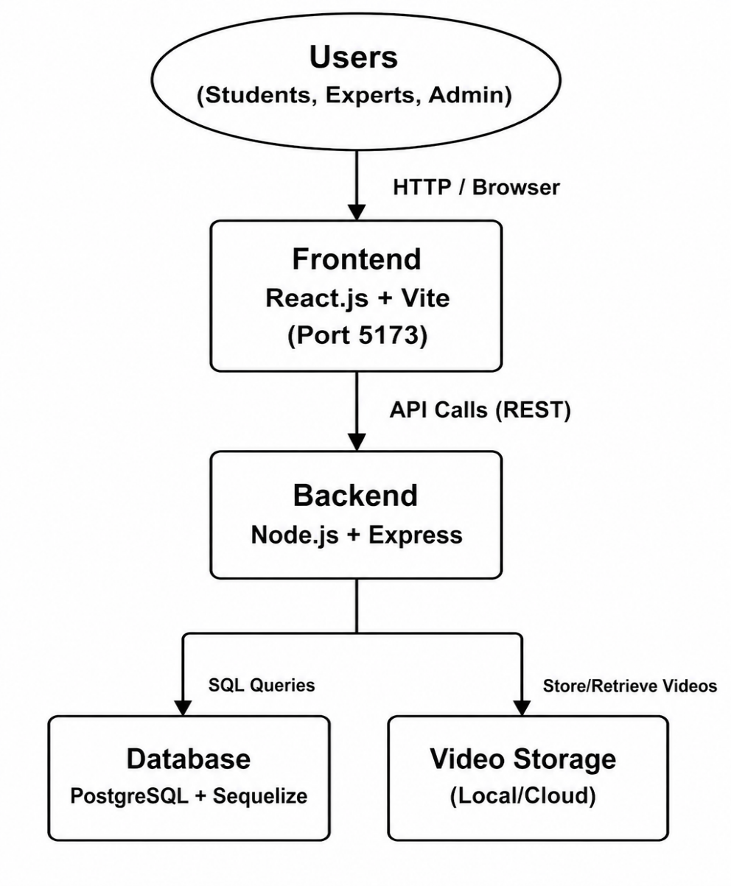
Figure 4.1-2: Architecture Diagram

Process Flow Representation
The Process Flow Diagram represents the role-based workflow of the SkillSync system, consisting of three primary user roles: Admin, Verified Expert, and Student. The flow begins with a login step, after which each user is directed to role-specific functionalities based on authentication and verification status.
For Admins, the process starts with JWT-secured sign-in, leading to the Admin Dashboard, where platform-wide operations are managed. Admins oversee student and expert accounts, manage instructor applications, verify lesson quality, and monitor system activity. Additionally, Admins manage system integrity by reviewing flagged content, moderating discussion forums, and validating expert credentials before they can publish material.
Once verified through the interview process, experts gain access to their management dashboard, enabling them to create new learning tracks, upload lessons, and monitor approval status. Experts submit content for review, after which the system publishes it upon admin approval. They can view enrollment progress, respond to student forum queries, and manage their own curriculum. Experts are notified whenever an enrollment occurs, a lesson is approved, or a student posts a question under their track.
Registered students can explore category-based learning tracks, apply various filters, and submit enrollment requests. They can view their profile, track learning progress percentages, and participate in discussion threads. After completing a track, students may receive verified badges, which document their learning journey within the platform.
The overall process flow ensures a structured, secure, and role-specific experience for all users, supporting smooth interaction, reliable information exchange, and efficient skill management across the application.
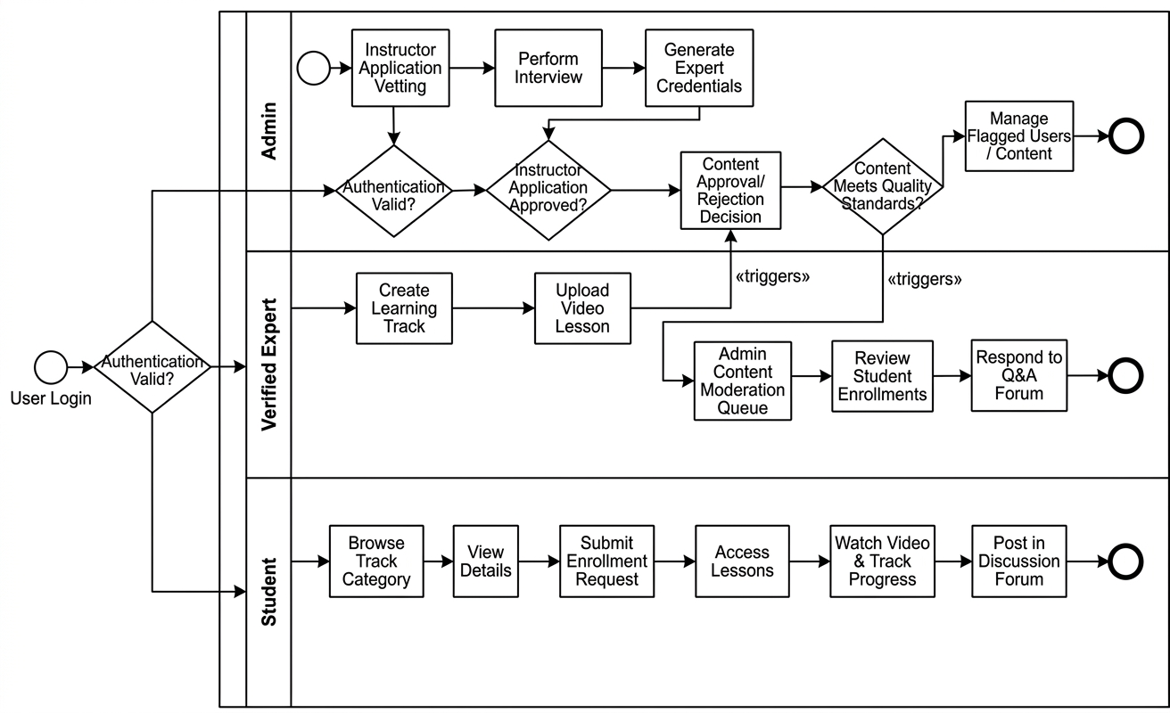
Figure 4.2-3:Process Flow Diagram

Sequence Diagram

The sequence diagram represents the operational flow within the SkillSync platform, focusing on the expert verification and lesson upload workflow, followed by the student learning process. The sequence begins when a user registers and submits an application to become a verified expert. This application is forwarded to the admin dashboard, where the admin reviews details and schedules an interview.
After the admin approves the expert, the system automatically issues credentials, enabling the instructor to navigate to the upload manager. When the expert uploads a video, the backend stores metadata in the database and the file in storage, setting the status to pending. If the admin approves the lesson after review, the status is set to approved and it becomes visible to students.
Once a student is enrolled, they can play videos, and the frontend requests signed streaming URLs from the backend. As the student watches, the system captures progress data such as watched seconds and updates the database in real-time. If the student posts a question in the forum, it is routed through the system to notify the expert for a response.
This sequence establishes a transparent, secure, and well-regulated process for handling both educational content and student interaction. It ensures that instructional material is authentic and verified while maintaining trust and accountability across the SkillSync platform.
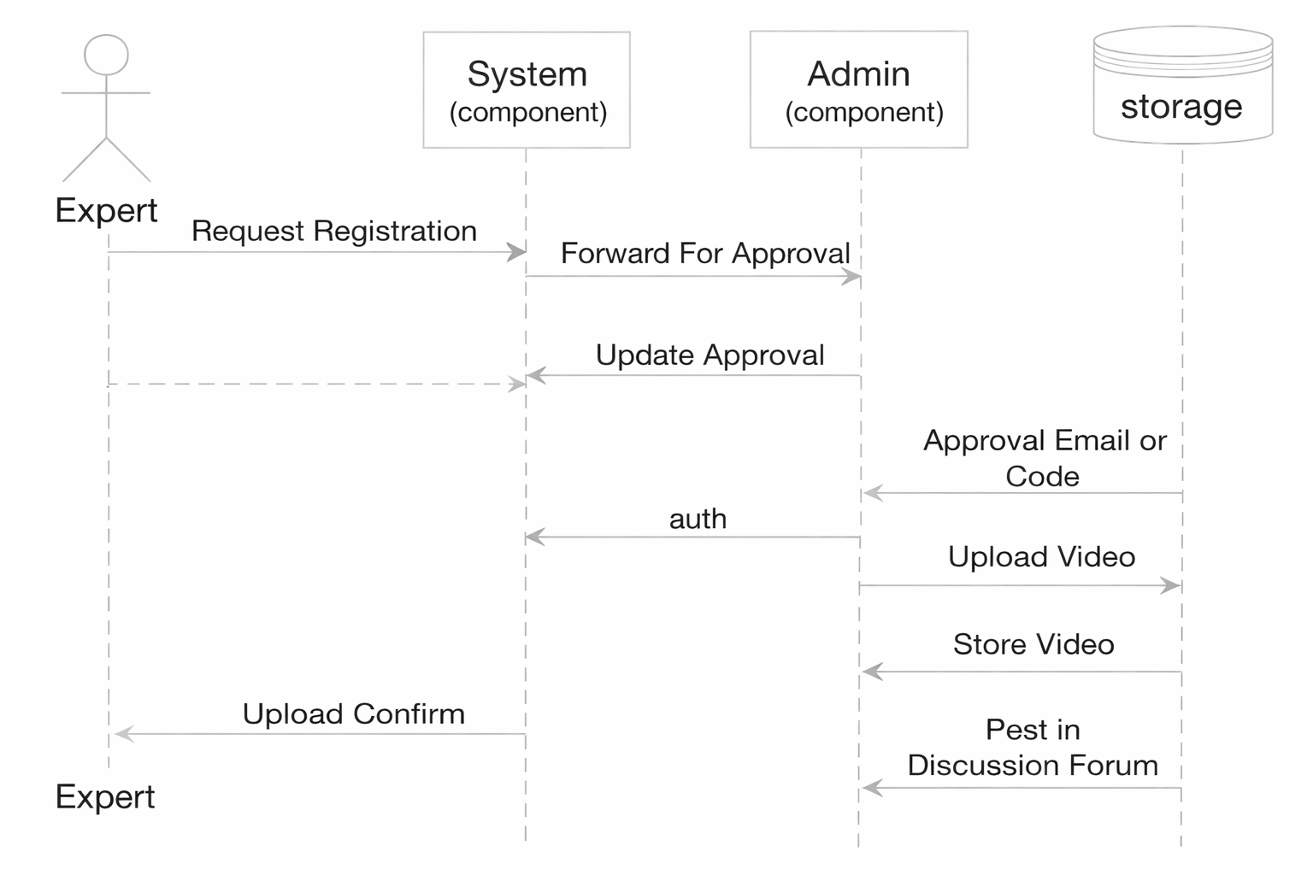
Figure 4.3 - 4: Property Rent Payment and Reviews

Class Diagrams
The provided class diagram represents the SkillSync system, illustrating the data structure and relationships among the main entities that support educational track management, expert verification, progress tracking, and student–expert communication. At the core of the model is the User class, which stores essential identity attributes along with email, hashed passwords, and roles (student, expert, admin).
Central to the system is the Video class, which contains instructional content details including title, storage URL, duration, and approval status. Each video is linked to an ExpertProfile (as the content creator) and a Category, ensuring lessons are organized into structured paths. The ExpertProfile class stores biographical info and verification status, linking back to the primary User entity.
Student learning actions are modeled through the Progress class, which represents the learning journey for each enrolled student. The class documents attributes such as watched seconds and completion boolean. Students engage with experts through the DiscussionPost and DiscussionComment classes. These entities store questions, responses, and related video references, facilitating role-based academic interaction.
Expert verification is supported by the ExpertCredential class, which records unique credential codes issued by admins for secure instructor access. To reward students, the system includes a Badge class and a UserBadge join class. These define criteria for completion and awarded timestamps, ensuring a gamified and structured reward system.
Overall, the class diagram ensures clear separation of responsibilities, encapsulation of functionality, and well-defined relationships among system entities. The design supports secure authentication, structured learning flows, verified instructor profiles, and moderated forums across all roles.
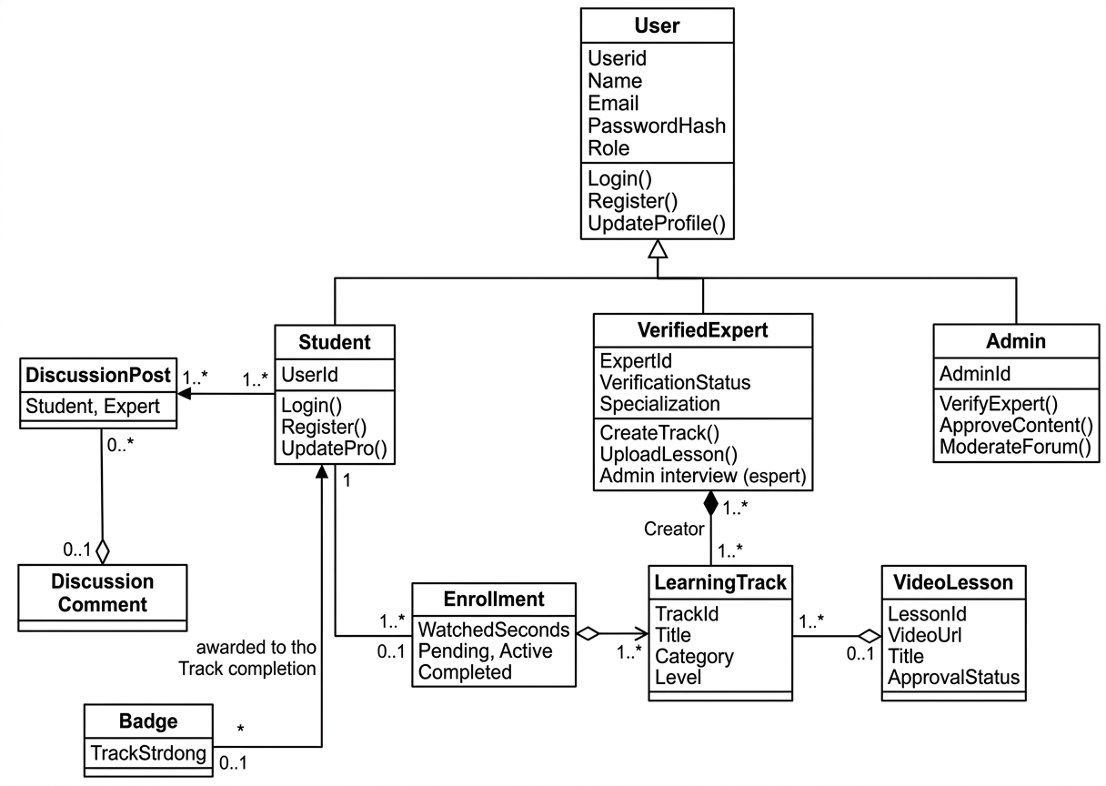
Figure 4.4 - 5: Class Diagram

62

Chapter 5 Implementation

Implementation
The implementation of SkillSync involved converting the system requirements and architectural design into a functional, interactive, and secure skill management platform. This phase ensured smooth integration of the backend with the user interface, reliable data handling, and seamless operations across students, verified experts, and administrators. Each module of the system was developed with a focus on performance, usability, and secure data management to create a dependable educational platform. The implementation phase involved multiple key steps as detailed below:

Setup of Development Environment:

Frontend Environment
The front end of SkillSync was developed using React.js with the Vite build tool, allowing for high-speed performance and modern development standards. This framework enabled the development of responsive interfaces that adjust smoothly to different devices and user roles, such as the student learning dashboard and the expert track manager. The frontend integrates directly with backend RESTful APIs to retrieve curated learning tracks, process enrollments, manage verification applications, and deliver real-time progress updates.

Backend Environment
The backend was developed using Node.js and Express, chosen for their scalability and flexibility in handling concurrent requests and video metadata processing. RESTful APIs were implemented to support all major operations, including JWT authentication, track management, enrollment workflows, forum interactions, instructor verification, and admin functions. Environment variables were used to secure sensitive keys, API endpoints, and database connections to maintain the integrity of the system.

Development Tools and Testing Setup
Testing environments were configured using Postman for API validation and PostgreSQL management tools for database verification. Email services were handled through specialized SMTP providers to ensure reliable delivery of enrollment and verification updates. JWT-based sessions were implemented to maintain secure, role-based authentication throughout the platform. This setup ensured consistency, security, and smooth development cycles during the implementation of the expert-led learning model.

Database Design and Implementation:

Database Structure

SkillSync uses PostgreSQL as its primary database due to its robust relational architecture and support for complex data integrity. Tables were created for users, verified experts, learning tracks, video lessons, enrollments, progress logs, discussion posts, and badges. Each table was structured using Sequelize models to enforce schema consistency, define relationships, and prevent unstructured or duplicate data entries.

Relationships and Data Integrity
Relationships between students, experts, and learning tracks were maintained using foreign keys and join tables, ensuring seamless cross-referencing for progress tracking. Learning track records store expert IDs, enrollment documents connect students and tracks, and progress logs link specific students to individual video lessons. These references ensure strong relational integrity, which is essential for calculating completion percentages and awarding verified badges.

Security and Access Rules
Access control was enforced using backend middleware and JWT-based authorization. Verified experts could modify only their own learning tracks, students could view only their enrolled progress, and admins managed platform-wide content moderation. Sensitive data, including hashed passwords and role-based permissions, was protected, and unauthorized access was restricted through strict route-level authorization checks.

User Authentication and Authorization:

OTP-Based Login Mechanism
SkillSync implements a secure JWT authentication system, where users provide their email and password to receive a role-signed session token. The backend validates the credentials using bcrypt hashing, generates the token with an expiration timestamp, and sends it to the frontend. This token is then used to authorize every subsequent request, ensuring that users can only access features permitted by their specific role.

Role-Based Access Control
Each authenticated user is assigned a specific role: student, verified expert, or admin. This role determines what actions they can perform within the system. Students access skill search and progress features, experts manage learning tracks and respond to student queries, while admins maintain platform-wide integrity, oversee expert vetting, and moderate uploaded content.

Session Management and Security
JWT tokens are used for session management, ensuring secure and stateless communication between the React frontend and the Node.js backend services. These tokens prevent unauthorized

access and expire automatically to reduce security risks associated with session hijacking. Middleware functions validate the token signature and role permissions before allowing any protected operation, such as lesson uploads or admin moderation.

User Interface Development:

Student Interface
The student interface provides an intuitive experience that simplifies the entire learning journey, starting from browsing curated skills to tracking course completion. The screen layout includes well-organized sections for skill discovery, where users can apply category filters, view track previews, read lesson descriptions, and monitor their learning history. The interface also integrates smooth navigation for enrollment, discussion forum engagement, and accessing earned badges. Interactive elements such as progress bars and achievement alerts guide students at every step, ensuring they can complete their tracks effortlessly.

Verified Expert Interface
The expert interface is structured to streamline track management tasks and help instructors maintain accurate and high-quality educational material. Experts can upload multiple video lessons, edit curriculum descriptions, update module orders, and monitor student enrollment data directly from their dashboard. The interface also includes dedicated sections for reviewing student progress and responding to discussion forum questions. Real-time indicators show pending lesson approvals, active tracks, and unread student queries to keep experts fully aware of their community activities.

Admin Interface
The admin interface provides comprehensive system oversight through a powerful web-based dashboard designed for quality control. Administrators can access detailed records of all user applications, lesson submissions, and moderation logs. The dashboard includes visual analytics that display trends such as new student registrations, approved expert applications, track completion rates, and platform-wide interaction levels. Each administrative tool is designed to ensure fast and accurate decision-making, including the vetting of expert credentials and the approval of instructional videos.

Learning Track and Enrollment Management:

Track Creation and Verification
Verified experts begin the track creation process by providing essential curriculum details such as titles, descriptions, categories, and video lessons. The system validates the uploaded metadata to

ensure formatting accuracy before storing it in the PostgreSQL database. Once submitted, the lessons are placed in a pending state where administrators review the content to verify instructional quality and confirm compliance with platform standards. This moderation process reduces the risk of low-quality or misleading content and ensures that students only interact with vetted material.

Student Search and Filtering
The search system offers students a sophisticated browsing experience by providing multiple filtering options, including skill categories and learning levels. The backend employs optimized relational queries to quickly retrieve matching results as the platform scale increases. Search results feature preview cards that display track highlights and expert information, enabling students to make informed choices before enrolling. The search system also organizes results to prioritize high-rated or trending tracks, improving the relevance of educational content for the user.

Enrollment Workflow
When students identify a suitable learning track, they can submit an enrollment request directly through the system. The backend links the enrollment to both the student and the track record, ensuring accurate progress tracking and accessibility. Verified experts receive updates regarding new enrollments and can monitor student movement through the lessons. Upon enrollment, students gain access to the discussion forums and full lesson content. The enrollment state is updated in the database to ensure that student dashboards accurately reflect their current learning commitments and history.

Instructor Verification System:

Expert Application Processing
Students wishing to become instructors initiate their application through a dedicated verification module within the SkillSync frontend. The user provides their credentials and professional background, which the backend securely stores. Administrators then access these applications to conduct the necessary vetting and interviews. Once the admin confirms the applicant's expertise, the user's role is updated in the system, granting them the specialized permissions required to create tracks and upload instructional material.

Admin Oversight and Content Validation
Administrators maintain complete oversight of the educational quality through a centralized moderation dashboard. Every lesson uploaded by an expert must pass an admin review before becoming live. This manual check ensures that the platform maintains its promise of "curated,

verified learning." Administrators have the authority to approve, reject, or request revisions on content, ensuring that only high-standard instructional videos reach the student community. This process builds trust and distinguishes SkillSync from unmoderated platforms.

Admin Oversight and Dispute Handling
Administrators maintain complete oversight of all transactions through secure Stripe dashboard integration and internal reporting tools. In cases of disputes, chargebacks, or refund requests, Stripe provides detailed logs that admins can use to investigate and take necessary action. Every transaction record, including refunds or disputed cases, is synchronized with the Rentofix database to maintain a transparent financial history. Admin oversight ensures platform-wide financial integrity and supports owners and tenants in resolving any payment-related concerns.

Discussion and Interaction Module:

Forum Participation and Douglas
After enrolling in a track, students gain access to the discussion forum interface, where they can provide written questions or insights regarding specific lessons. The post is automatically linked to the corresponding track, ensuring that interaction remains contextually relevant. Additional metadata such as timestamps and user roles is stored to maintain a traceable history. This process ensures that students can clear their doubts effectively and encourages active participation within the learning community.

Moderation and Expert Response
Once a student posts in the forum, verified experts can examine the query and provide authoritative responses directly within the thread. This dual-layer interaction ensures that students receive accurate help from subject matter experts. Administrators have final oversight and can moderate discussion posts based on language standards or community guidelines. This validation prevents spam or off-topic content and maintains the integrity of the academic interaction environment.

Notification and Progress Tracking Module:

System Notification Delivery
All system-generated notifications are delivered to users via secure in-app alerts and email updates. When a student receives an enrollment confirmation, when an expert obtains content approval, or when an admin issues a verification update, an automated notification is triggered through the backend. These alerts provide clear information, allowing all roles to stay updated on track progress and account status. This method ensures consistent communication throughout the learning lifecycle.

Persistent Learning History and Progress
Since progress is tracked at the lesson level, students retain a complete history of their learning journey directly on their dashboard. The system automatically recalculates completion percentages as students finish modules, eliminating the need for manual tracking. Users can revisit their progress at any time, ensuring transparency and providing a clear path toward track completion. This persistent history also supports the automated awarding of verified badges upon reaching course milestones.

Admin Panel and System Management:

Expert and Content Management
Admins have full authority to review instructor applications and learning tracks before they are approved for public visibility. This includes evaluating expert backgrounds, checking curriculum accuracy, and ensuring that uploaded videos meet resolution and quality standards. Admins also manage student accounts, resolve profile issues, and act against reported content or suspicious activity. This oversight helps maintain a trustworthy environment and ensures that all educational material on the platform is authentic.

Algorithm
The general algorithm flow for the SkillSync system is as follows:
- Start the application and display the splash screen.
- Route the user to the JWT authentication module.
- Authenticate the user and load the appropriate role-based dashboard (Student / Verified Expert / Admin).

If Student:
  - Explore available learning tracks based on categories and levels.
  - View detailed track profiles, lesson previews, and expert information.
  - Submit enrollment requests to gain full access to tracks.
  - Track learning progress via percentage bars and module completion.
  - Participate in discussion forums and receive verified badges.

If Verified Expert:
  - Apply for instructor verification and complete the admin interview process.
  - Add new learning tracks with structured video lessons and modules.
  - Monitor the approval status of uploaded content.
  - Respond to student queries in the discussion forums.
  - View enrollment analytics and monitor student progress across tracks.

If Admin:
  - View and verify instructor applications and content submissions.
  - Conduct expert vetting and manage role-based permissions.
  - Moderate discussion forums and handle flagged content or reports.
  - Generate system-wide analytics to monitor platform quality and growth.
- Access the notification module for real-time updates on enrollments, approvals, and interaction.
- Logout and terminate the secure session.

User Interface
The Rentofix interface is designed to provide a seamless, modern, and intuitive experience for Tenants, Property Owners, and Administrators. The design emphasizes simplicity, clean layouts, and responsive navigation, making it easy for users to browse properties, manage listings, submit booking requests, and access admin tools.

Authentication Interface Screens
The authentication interface in Rentofix is designed to provide secure, user-friendly access for tenants, property owners, and administrators. The screens follow a clean and professional layout, ensuring that users can easily navigate through login, registration, and OTP verification processes.

Registration Screen:
The registration screen allows new users to create an account by entering their name and email address. 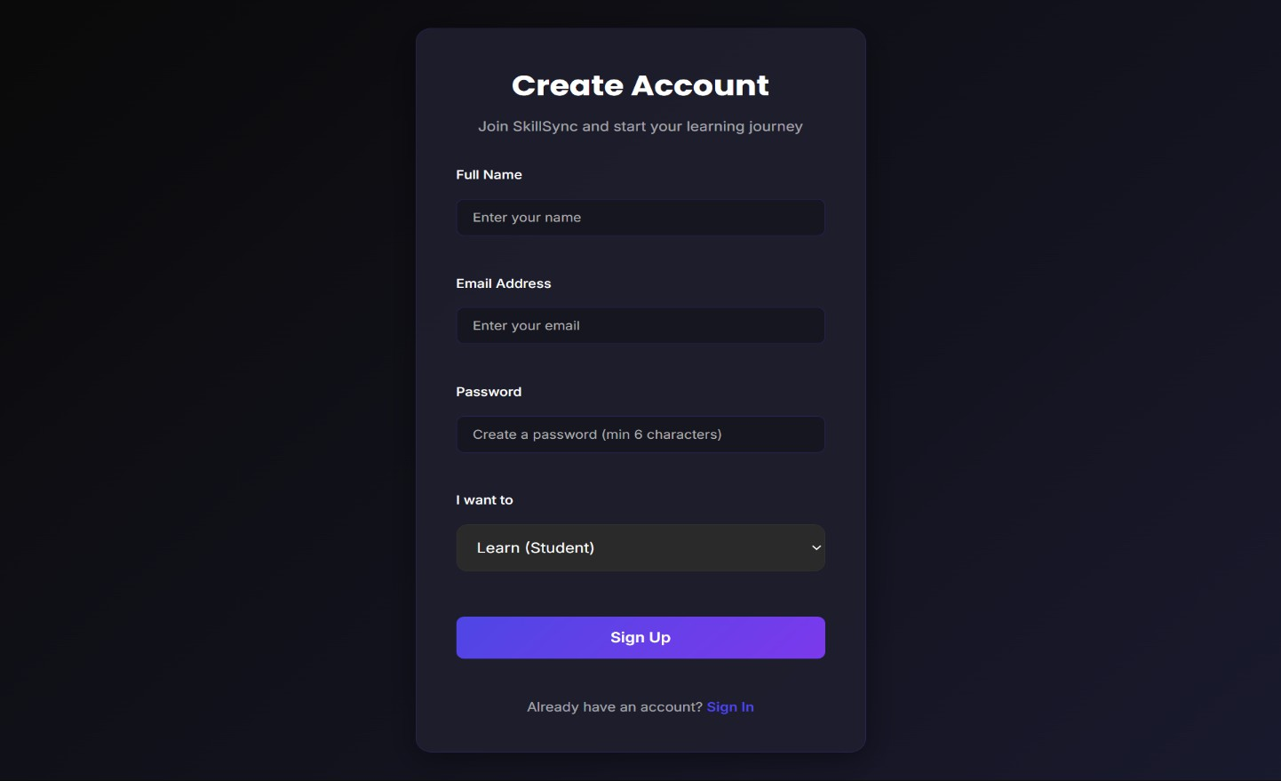
Figure 5.11.1 - 6: SignUp Page

Login Screen (Password-Based Authentication):
All existing users log in using their email and password. Login is the same for both Tenants and Property Owners, with role-based redirection happening after authentication automatically.
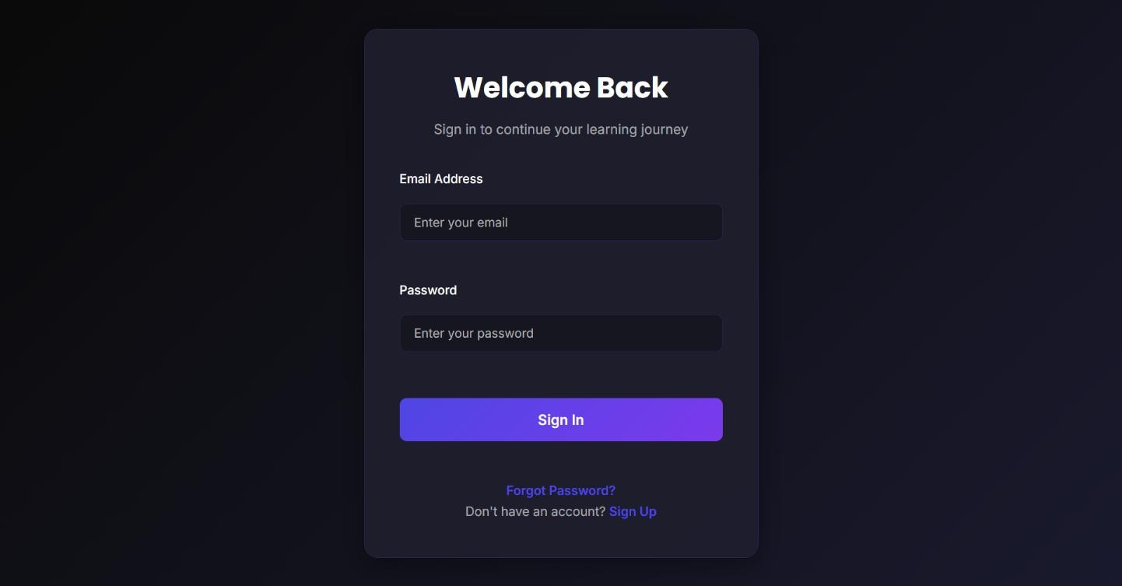
Figure 5.11.1 - 7: Login Screen

Admin Interface Screens
The Admin Control Panel is the command center of SkillSync. It provides a high-level overview of platform growth and granular control over all user roles, content quality, and platform integrity:

Admin Overview Dashboard:
The Overview tab serves as the primary analytics hub, featuring summary tiles that track total student enrollment, instructor count, pending approval queues, and the total number of live courses. This bird’s-eye view allows admins to monitor platform activity at a glance.

User & Content Management:
The Admin panel includes dedicated views for managing Students and Instructors. The Students view lists all registered learners with their enrollment history and account status. The Instructors view includes a vetting system where admins can review pending applications and manage active experts.

Course & Report Moderation:
Admins can browse the full Course Catalog to delete low-quality content. Additionally, the Reports section acts as a quality control hub where student-submitted complaints regarding specific lessons are reviewed and resolved to maintain high educational standards.
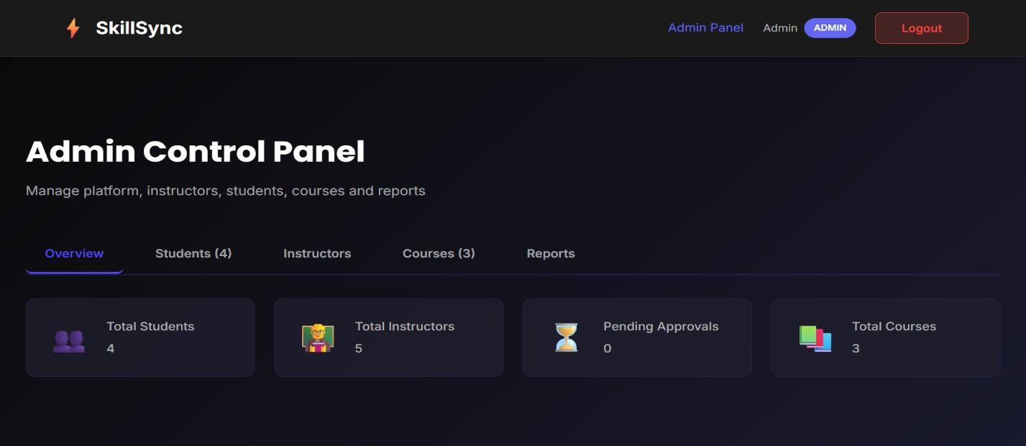
Figure 5.11.2 - 8: Admin Overview Dashboard

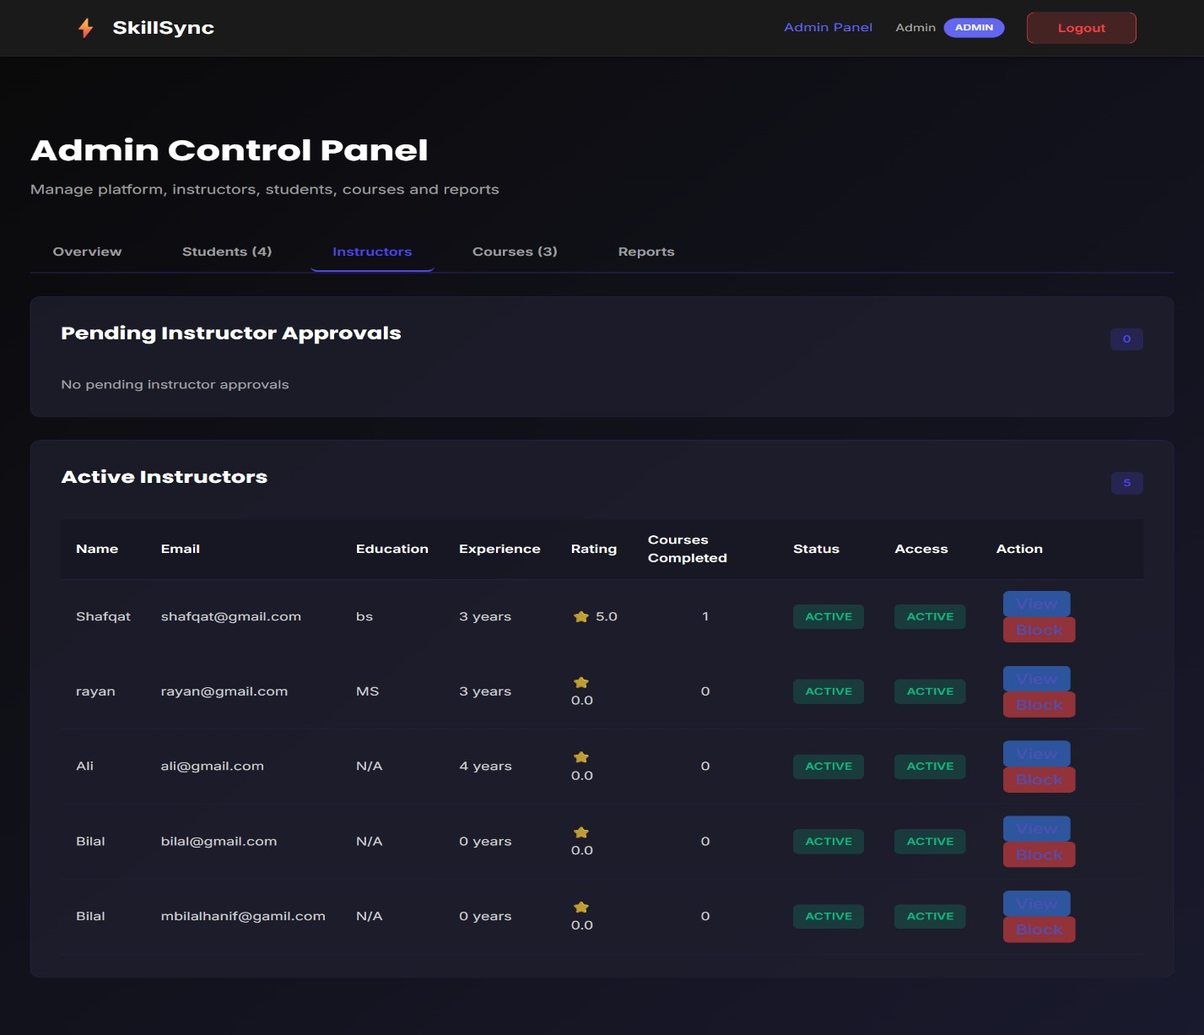
Figure 5.11.2 - 9: Admin Instructor Management & Approvals
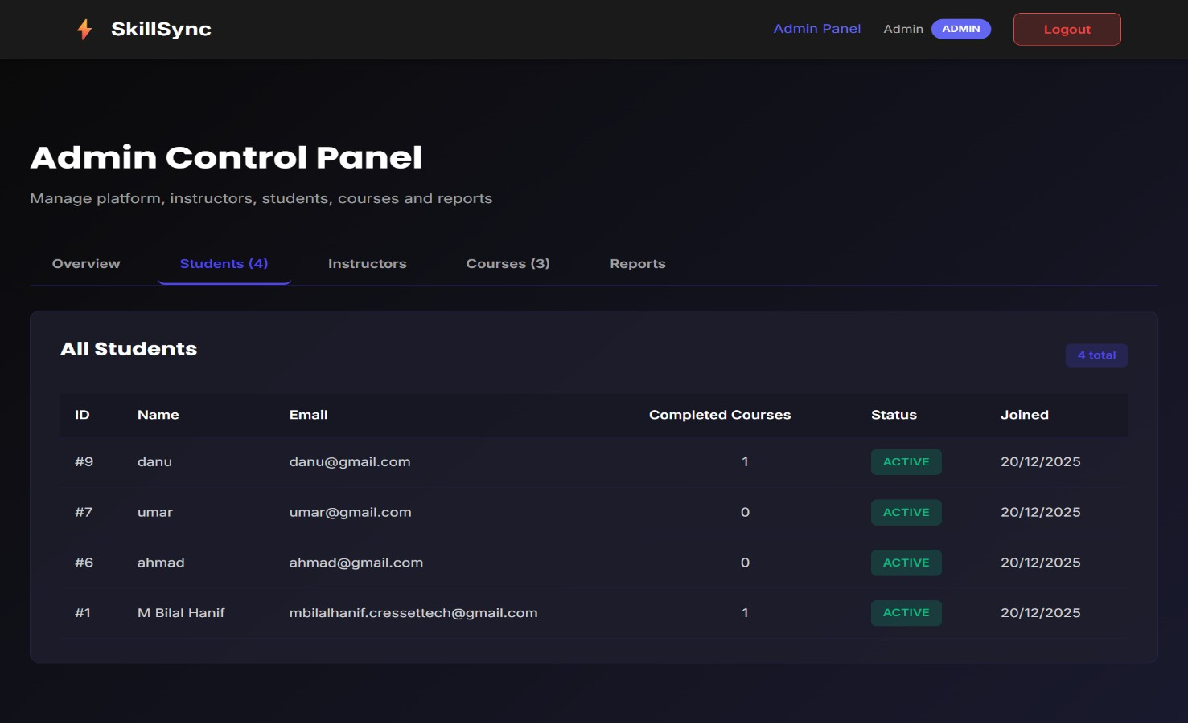
Figure 5.11.2 - 10: Admin Student Management Screen
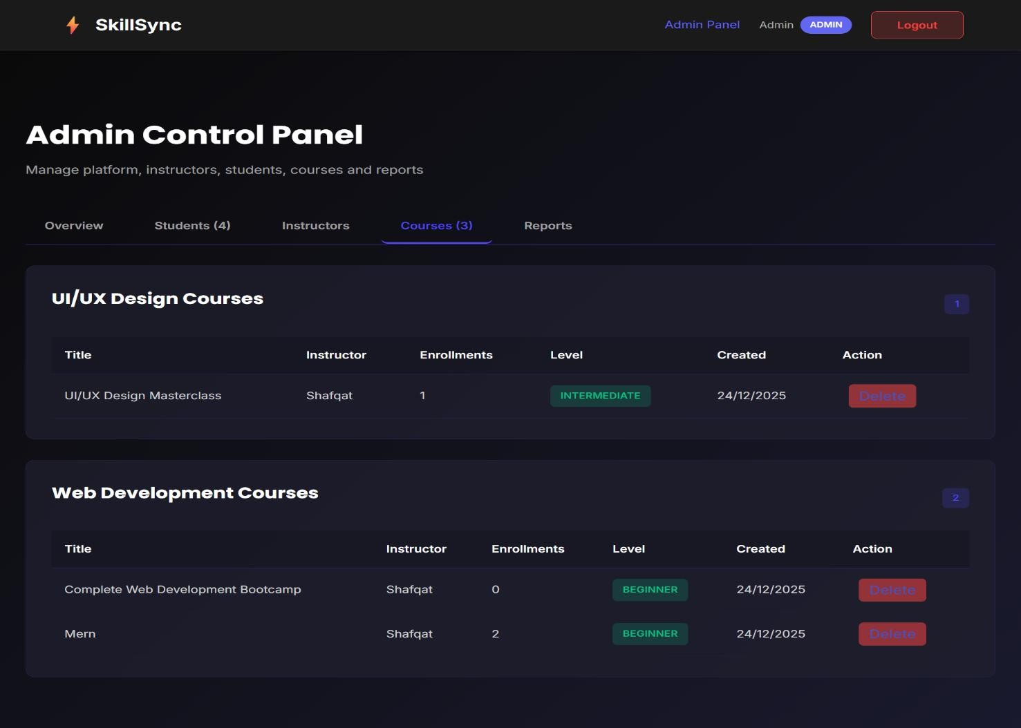
Figure 5.11.2 - 11: Admin Course Control Panel
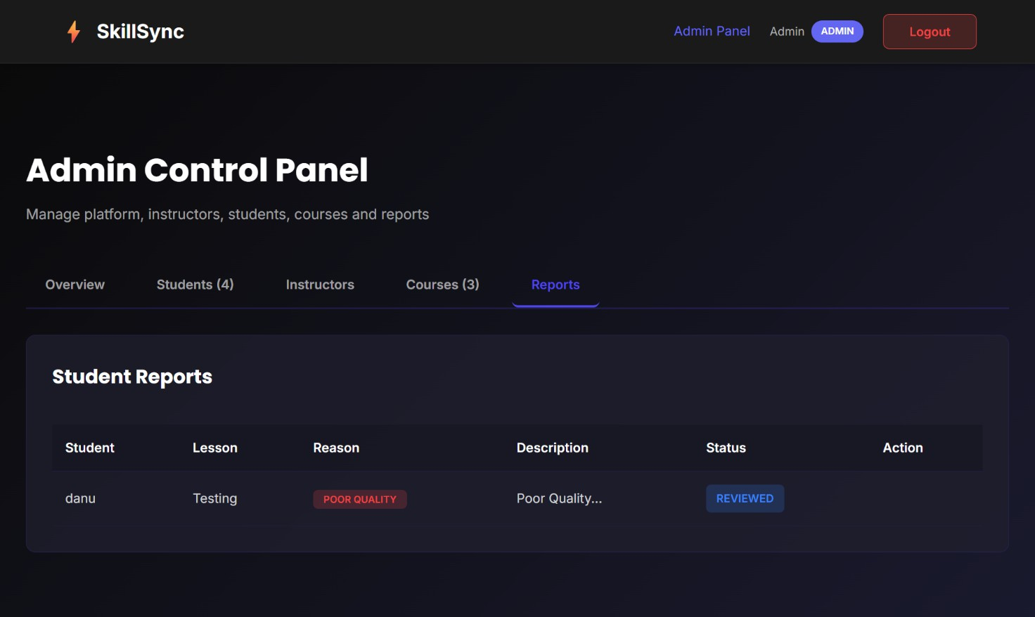
Figure 5.11.2 - 12: Admin Student Reports & Moderation Screens

Instructor (Expert) Interface Screens
The Instructor Interface is designed for content creators to manage their educational portfolio and interact with their students. It balances powerful management tools with a simplified workflow:

Instructor Dashboard:
The main dashboard displays the instructor's key performance metrics, including total students reached and years of experience. A "Your Courses" section allows for rapid content management, providing buttons to upload new material, view student progress, or edit course metadata for existing tracks.

Student Interaction Hub:
The messaging system allows instructors to provide direct mentorship. It features a split-pane layout where instructors can select specific students to view conversation histories, ensuring that learner doubts are addressed in a timely and organized manner.

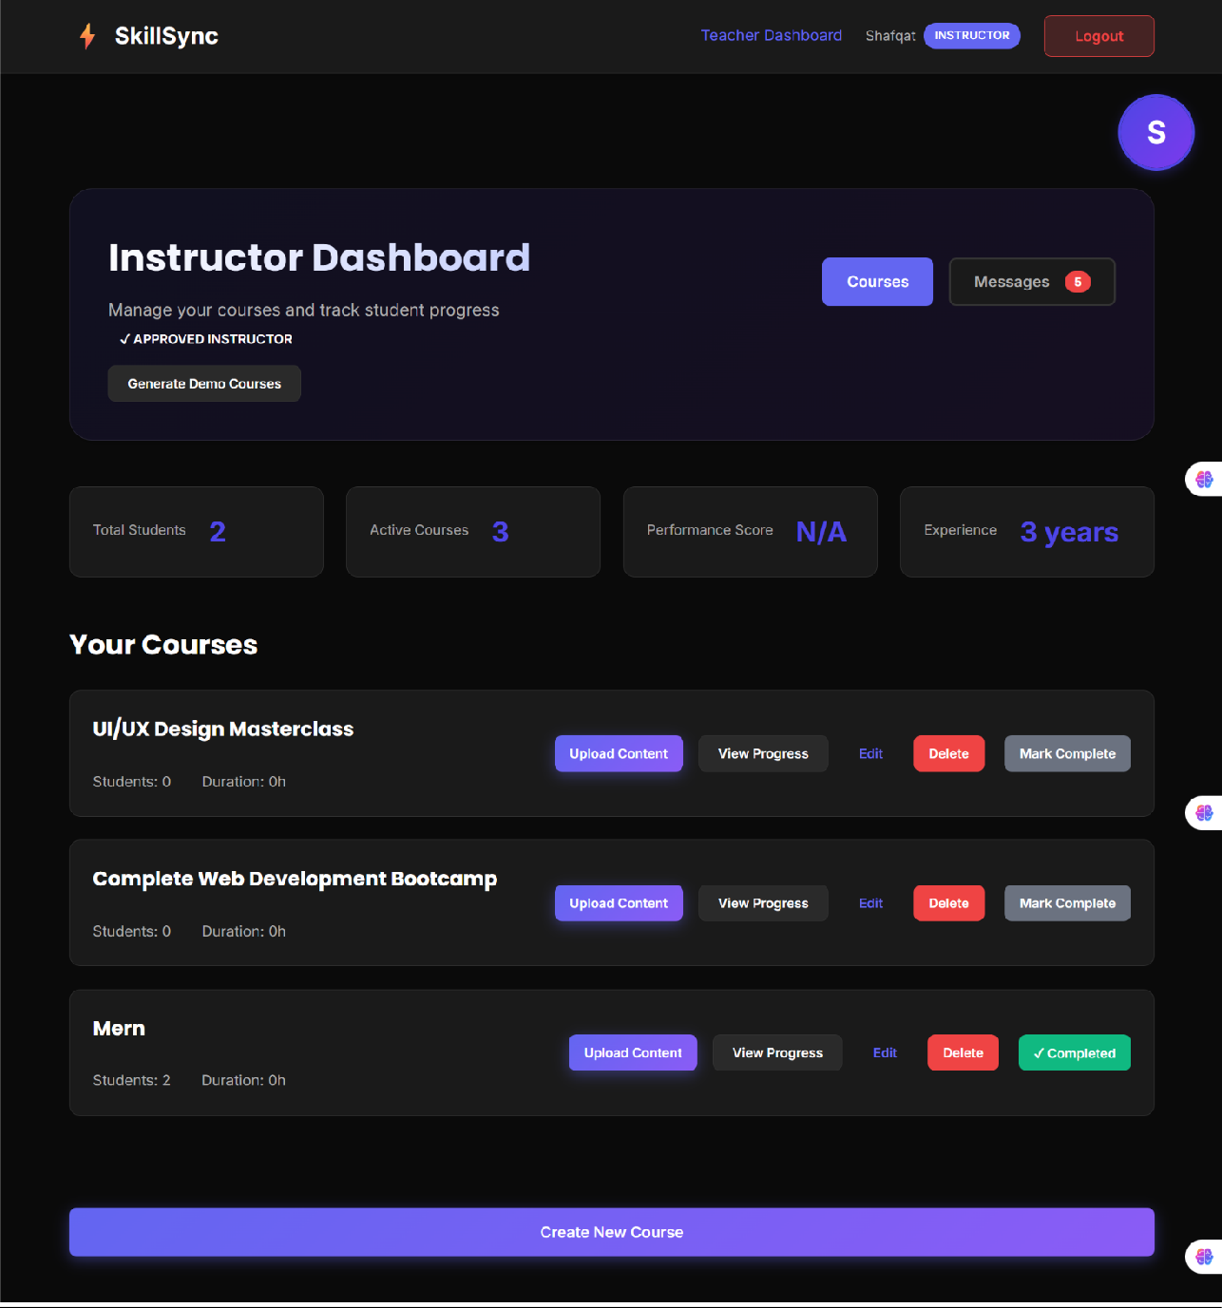
Figure 13 Instructor Dashboard & Course Management
Figure5.11.3 - 13: Instructor Dashboard & Course Management

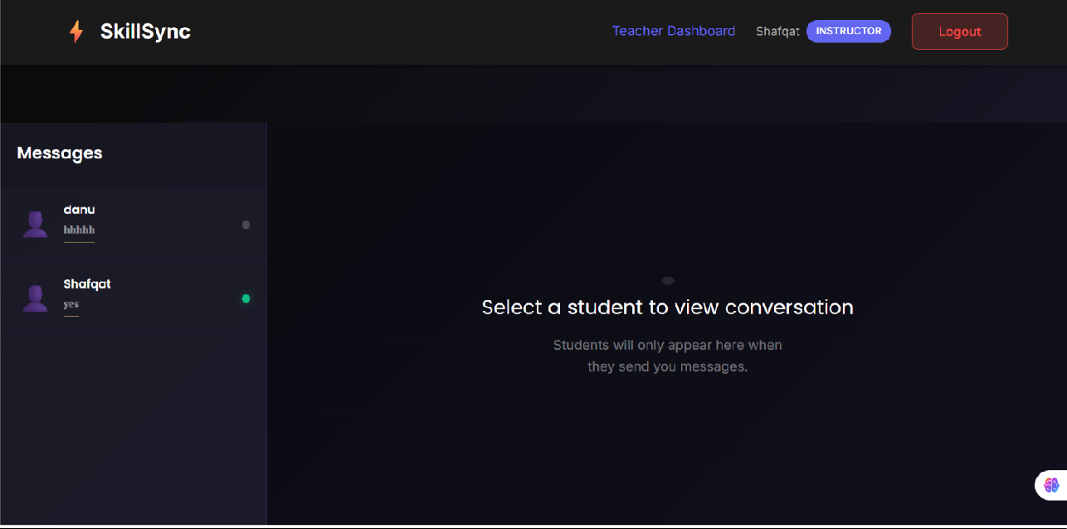
Figure 5.11.3 - 14: Instructor Communication & Messaging Hub

Student Interface Screens
The Student Interface focuses on discovery, learning, and achievement. It provides a seamless journey from browsing the landing page to earning a verified credential.

SkillSync Landing Page (Hero):
The public-facing portal features a dynamic hero section that highlights the platform's value proposition. It categorizes "Skills We Teach" (e.g., MERN, UI/UX) and offers structured "Learning Paths" to guide students from beginner to expert levels.

Certificates & Achievement Tracking:
The "My Certificates" page lists all successfully completed courses, providing a sense of progression. Students can view their certificate history and access a professional Certificate Preview, which generates a verified SkillSync Academy credential featuring the student's name, the instructor's signature, and a unique Credential Identifier for LinkedIn sharing.

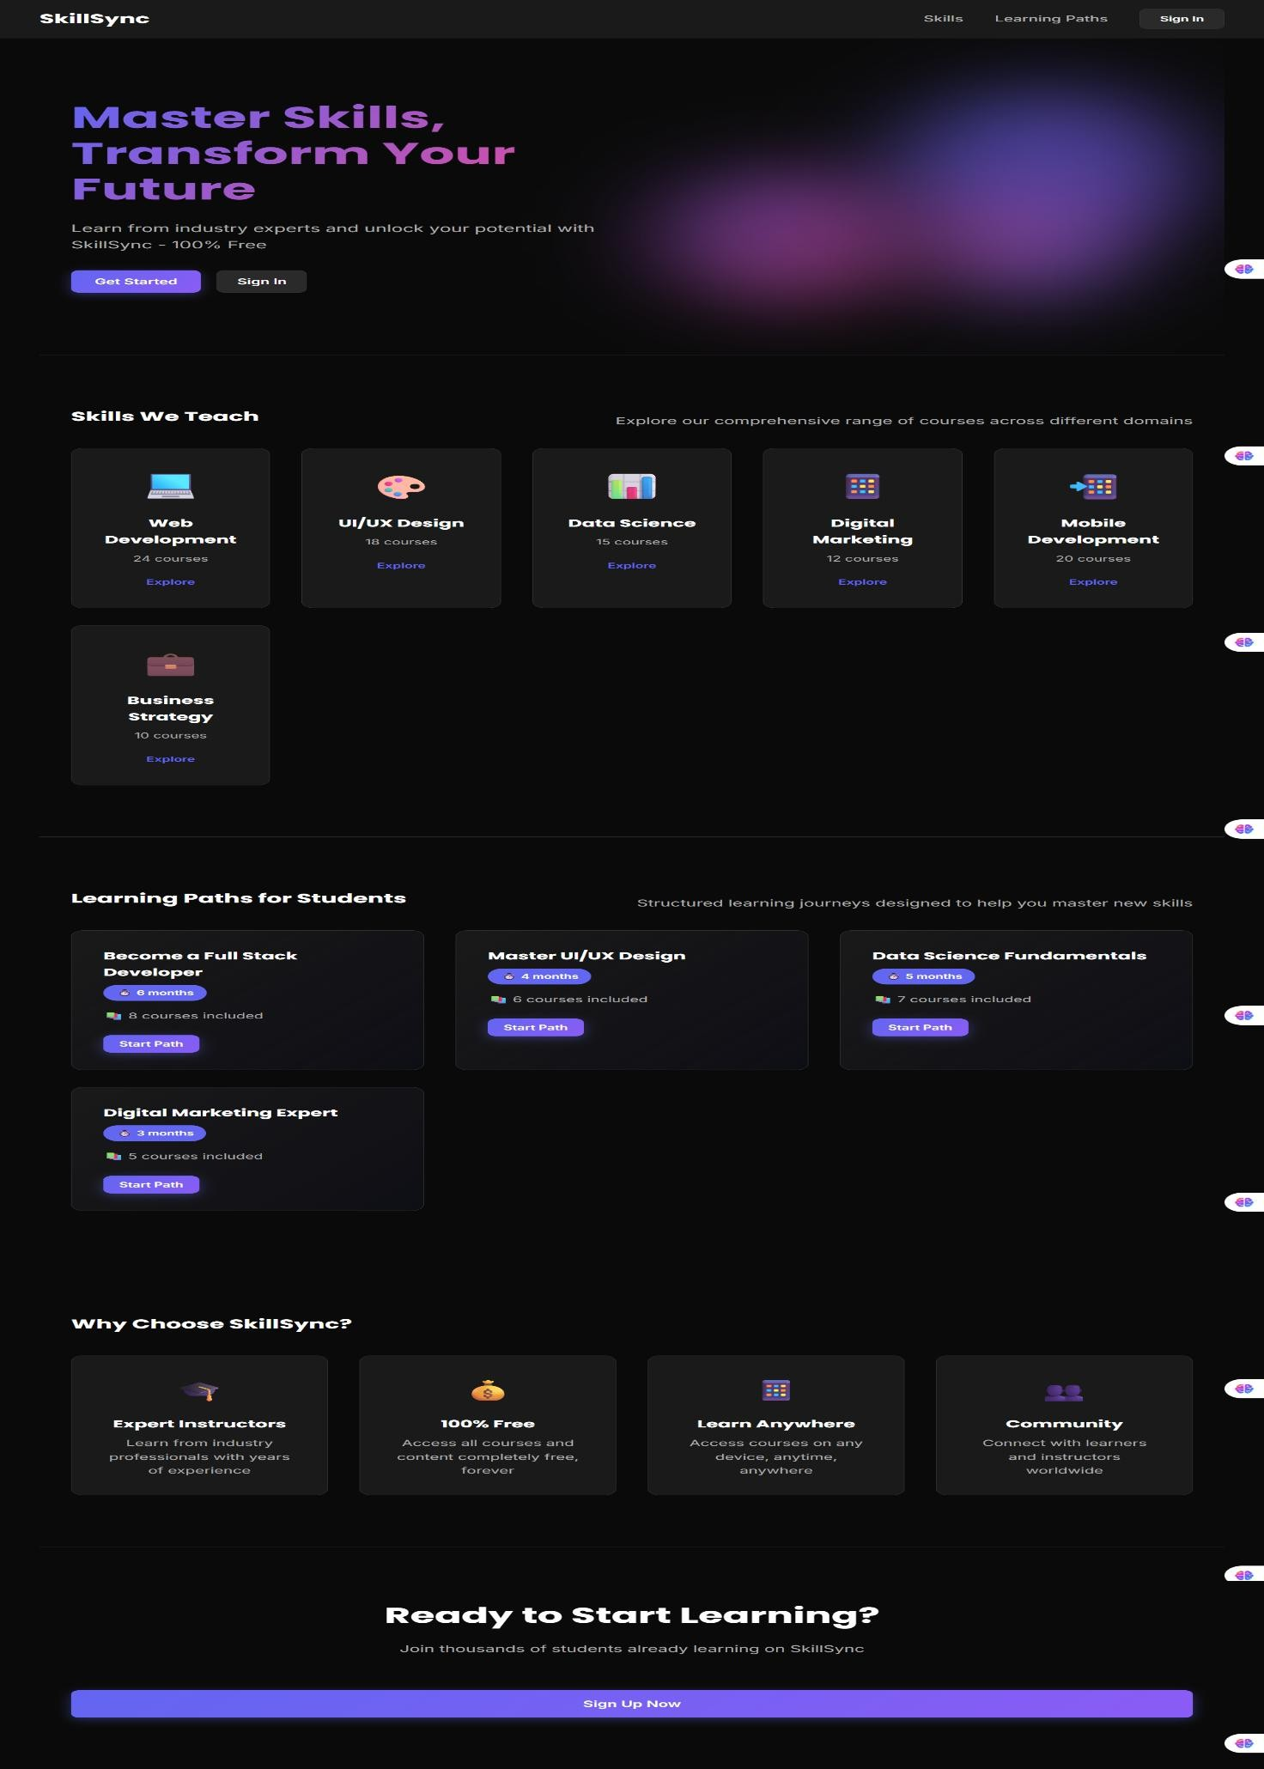
Figure 5.11.4 - 15: SkillSync Landing Page & Learning Path

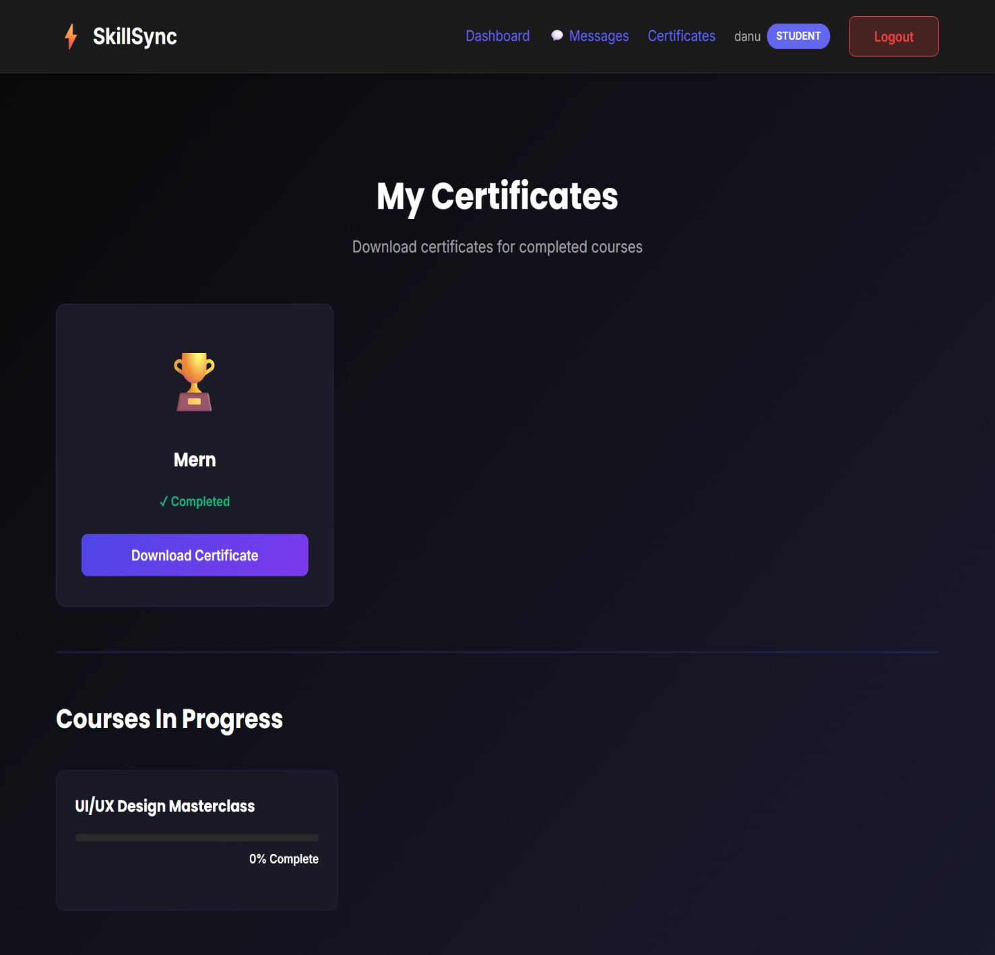
Figure 5.11.4 - 16: Student Certificate History & Progress

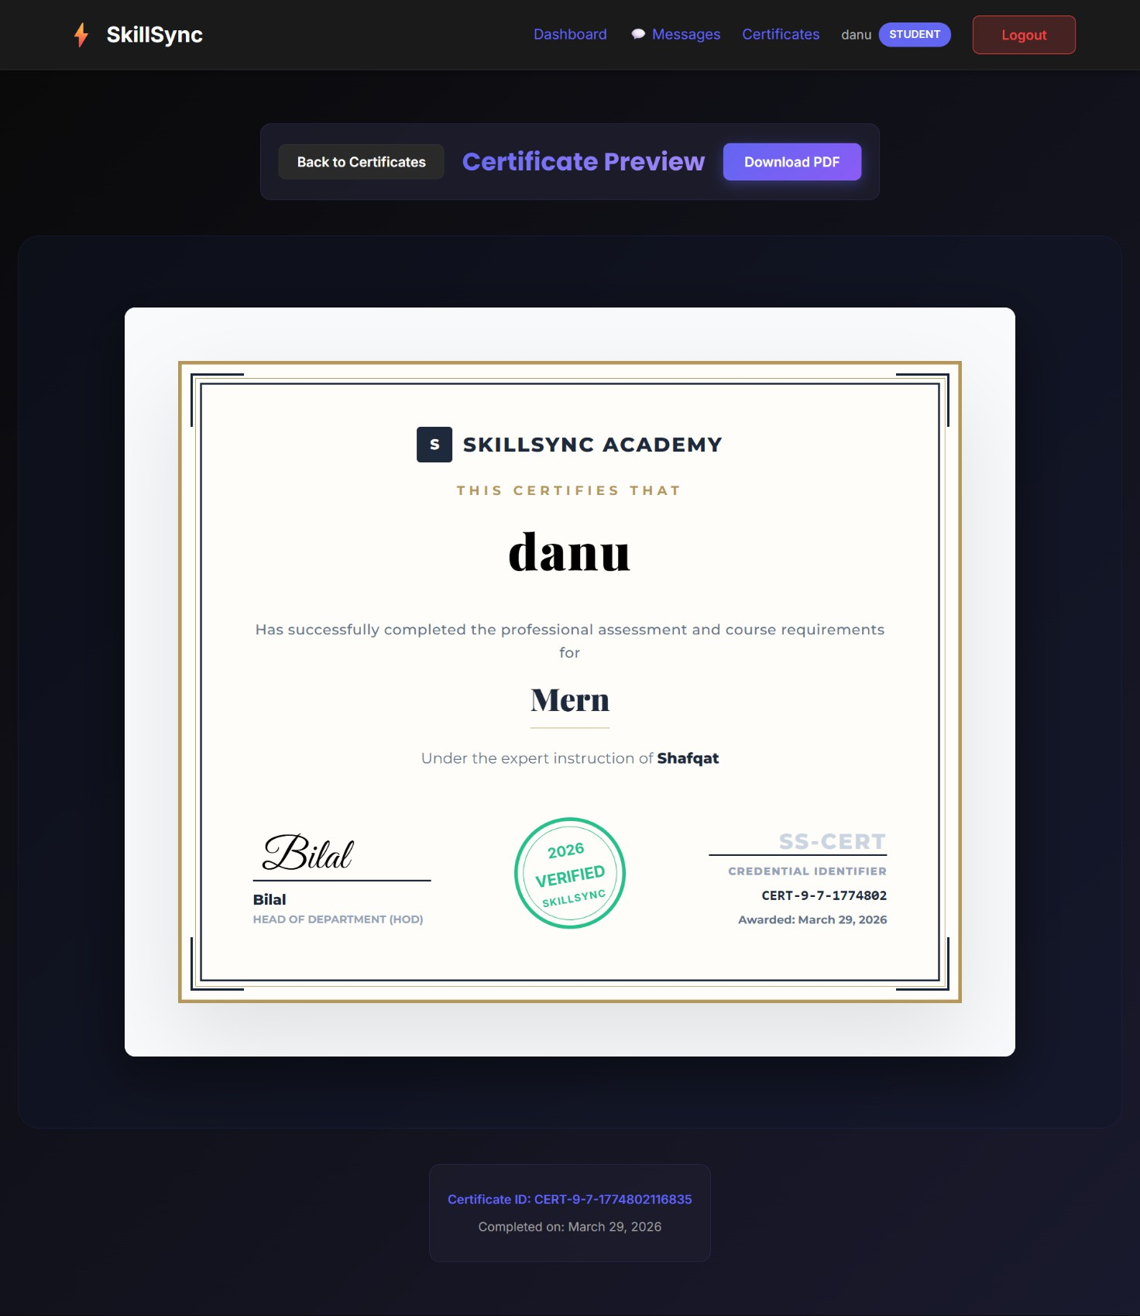
Figure 5.11.4 - 17: Verified Certificate Preview Screen

79

Chapter 6 Testing and Evaluation

Testing and Evaluation
The testing and evaluation phase of SkillSync, a curated platform for skill-based learning, ensures that the system performs reliably, meets all functional and non-functional requirements, and provides a seamless experience for students, verified experts, and administrators. Various testing methodologies, including manual testing, unit testing, functional testing, and integration testing, were applied to validate platform stability, content accuracy, and usability. This chapter summarizes the overall testing approach and presents the results of test execution conducted on the core educational modules.

Manual Testing
Manual testing was carried out to validate the core workflows of SkillSync without using automated tools. This helped verify that each module performs as intended and provides accurate responses during real user interactions. User operations such as student registration, instructor verification applications, track creation, video streaming, and admin content moderation were tested thoroughly. The table below summarizes the major manual test cases and their outcomes.
Table 6.1 - 22: Manual Testing
Test Cases | Expected Result | Actual Result | Status
Expert Registration | Successful signup as student | Successful | Pass
Expert Application | Admin receives application for vetting | Received | Pass
Student Login | Secure JWT-based dashboard access | Successful | Pass
Admin Login | Access to moderation and vetting panels | Successful | Pass
Track Creation | Expert can upload videos and set metadata | Successful | Pass
Admin Verification | Admin approves/rejects lesson status | Status updated | Pass
Skill Search | Accurate results based on category filters | Accurate | Pass
Enrollment Request | Track added to student dashboard | Track added | Pass
Video Progress | System updates watched percentages | Works as expected | Pass
Forum Posting | Question stored and visible in track forum | Published | Pass
Badge Awarding | Badge issued upon 100% completion | Badge awarded | Pass
Support Chat | Users can contact admin for assistance | Message delivered | Pass

Unit Testing
Unit testing focuses on validating each standalone module of the SkillSync system. Each unit, such as registration logic, progress calculation, and enrollment submission, is tested individually to ensure accuracy within isolation.
Table 6.1.1 - 23: Unit Testing
Test Case ID | Test Case Name | Expected Result | Actual Result | Status
UT-001 | Expert Signup | Student account created initially | Successful | Pass
UT-002 | JWT Token Gen | Valid token returned on login | Token generated | Pass
UT-003 | Category Loading | Correct skill categories display | Loaded correctly | Pass
UT-004 | Video Upload | Metadata saved and stored in DB | Stored correctly | Pass
UT-005 | Progress Calc | Percentage updates on lesson finish | Updated correctly | Pass
UT-006 | Admin Vetting | Status flag changes on moderation | Updated correctly | Pass
UT-007 | Filter Logic | Accurate list for specific categories | Results accurate | Pass
UT-008 | Enrollment Save | Enrollment linked to UserID and TrackID | Record saved | Pass
UT-009 | Forum Submission | Question saved with valid TrackID | Post saved | Pass
UT-010 | Badge Issue | User-Badge join table updated | Updated correctly | Pass
UT-011 | Password Hash | Bcrypt secures password before storage | Hashed successfully | Pass

Functional Testing
Functional testing ensures that every core feature of the SkillSync platform operates according to defined requirements and delivers the expected experience for students, experts, and administrators.
Table 6.1.2 - 24: Functional Testing
Test Case ID | Test Case Name | Expected Result | Actual Result | Status
FT-001 | Expert Role Apply | Application moves to admin queue | Logic successful | Pass
FT-002 | Track Submission | Lessons stay pending until approved | Correct transition | Pass
FT-003 | Admin Content Rev | Admin can watch and approve videos | Works as expected | Pass
FT-004 | Student Skill Search | Search returns only approved tracks | Accurate results | Pass
FT-005 | Progress Tracking | Sidebar shows completion checkmarks | Displayed correctly | Pass
FT-006 | Forum Doubts | Expert receives alert for new posts | Alert received | Pass
FT-007 | Admin Moderation | Admin can hide inappropriate posts | Post hidden | Pass
FT-008 | Dashboard Sync | Enrolled tracks show on main page | Synced perfectly | Pass
FT-009 | Logout Security | JWT cleared and session terminated | Logged out | Pass

Integration Testing
Integration testing ensures that all connected modules of the SkillSync platform operate together smoothly and that data flows accurately across the entire student-expert ecosystem.
Table 6.1.3 -25: Integration Testing
Test Case ID | Test Case Name | Expected Result | Actual Result | Status
IT-001 | Reg & RBAC Flow | Role update grants correct permissions | Successful | Pass
IT-002 | Upload & Approval | Content moves from Expert → Admin → Student | Smooth workflow | Pass
IT-003 | Search & Enrollment | Filtered search leads to enrollment | Integrated correctly | Pass
IT-004 | Video & Progress | Watching video updates completion badge | Works correctly | Pass
IT-005 | Forum & Experts | Student post triggers expert response | Delivered | Pass
IT-006 | Admin Dashboard | Real-time analytics reflect new uploads | Data accurate | Pass
IT-007 | Database & UI Sync | Progress updates appear instantly on UI | UI synced | Pass

Automated Testing
Due to project constraints and the focus on core educational logic involving React, Node.js, and PostgreSQL, only limited automation testing was implemented in the SkillSync platform. While automated testing provides faster execution for large-scale applications, the SkillSync system was primarily validated through comprehensive manual test cases that covered all essential workflows, including authentication, track management, progress tracking, and role-based access.
However, basic automation scripts using Jest were created for selected backend APIs such as registration, login, and enrollment linking, helping ensure stability after updates. These automated checks verified that the core endpoints responded correctly and maintained data consistency. Despite the partial use of automated tools, the overall quality and reliability of the platform were ensured through detailed manual testing in real user learning scenarios
.

Chapter 7 Conclusion and Future Work

Conclusion and Future Work

Conclusion
SkillSync is a modern skill management platform designed to simplify and streamline the interactions between students, verified experts, and administrators. The system successfully addresses the challenges faced in traditional unmoderated learning workflows by digitalizing expert vetting, content discovery, enrollment requests, progress tracking, and forum support. By incorporating secure JWT authentication, admin-led content verification, and real-time learning analytics, SkillSync provides a unified ecosystem for transparent, efficient, and reliable skill development.

Technical Architecture:
SkillSync accomplishes its objectives through a feature-rich, scalable, and responsive architecture. The platform provides secure, role-based authentication with session mapping for three distinct user types. Instructors manage tracks through a structured verification model where content undergoes admin review to prevent misinformation. Students discover skills through category filters and track their learning history through automated dashboards. Finally, the forum interaction and badge systems ensure that learning is interactive and rewarded upon completion. Overall, the platform meets its functional goals and provides a user-friendly and secure educational experience.

System Architecture Overview:
SkillSync operates on a modern architecture built using the MERN-variant stack (PostgreSQL, Express, React, Node), ensuring fast performance and reliable data handling. The backend handles all API operations and communication between system modules using Sequelize ORM. PostgreSQL securely stores user accounts, video metadata, and progress records. For the frontend, React.js provides dynamic dashboards tailored for each role. Authentication is strengthened using JWT and secure hashing. To manage video content, SkillSync uses local storage during development with a production-ready path for AWS S3. This cloud-aligned approach ensures consistent performance and scalable storage for visual content.

Future Work
The current version of SkillSync fulfills its primary goals, but there remains significant potential for enhancement as educational trends evolve. Future development will focus on the following strategic areas:

AI-Powered Learning Recommendations
Future versions can benefit from integrating AI to provide personalized track suggestions. By analyzing student preferences, browsing history, and completion behavior, the system could automatically recommend the most relevant skills.

Dynamic Content and Revenue Models
To help experts monetize their knowledge, SkillSync can incorporate payment modules and dynamic pricing for premium tracks, optimizing instructor revenue while keeping foundational content accessible.

Integrated Mentorship and Maintenance
Introducing a dedicated mentorship module would allow students to book 1-on-1 sessions with experts directly. This would create a deeper interaction channel for handling complex learning roadblocks.

Enhanced Interaction with Voice & File Sharing
The forum system can be upgraded to include voice notes and file sharing for code snippets or design assets. Automated bots can be integrated to handle common student queries instantly.

Advanced Admin Analytics
The administrative dashboard can be improved with deeper visual reporting, including heatmaps of student engagement and automated fraud detection for uploaded content.

Mobile Application Version
Developing a mobile application for Android and iOS would significantly improve learner convenience, allowing students to access lessons and notifications on the go with offline sync capabilities.

KYC and Credential Automation
Future iterations could integrate automated identity verification for instructors to streamline onboarding while maintaining the high trust standards of the platform.

Smart Geo-Location and Localized Skills
Intelligent tools could offer location-aware skill recommendations based on regional job market demands, making the search experience more career-driven.

Augmented Reality (AR) Skill Previews
Integrating AR into SkillSync could offer students an immersive way to preview practical skills such as technical repairs or design layouts in a 3D environment before enrolling.

References
- React.js Documentation. (2024). Building User Interfaces with React.
Retrieved from: https://react.dev/learn/
- Node.js Documentation. (2024). Building Backend Services and REST APIs with Node.js.
Retrieved From: https://nodejs.org/en/
- MongoDB. (2023). Data Modeling and NoSQL Design Patterns.
Retrieved From: https://www.mongodb.com/docs/manual/data-modeling/
- Express.js. (2023). Express Web Framework Documentation.
Retrieved From: https://expressjs.com/
- Cloudinary. (2024). Image and Video Management for Developers.
Retrieved From: https://cloudinary.com/documentation/
- JWT IETF Standard. (2023). JSON Web Token (JWT) Authentication.
Retrieved From: https://www.jwt.io/introduction/
- WebSocket. (2024). Real-Time Communication in Web Applications.
Retrieved From: https://developer.mozilla.org/en-US/docs/Web/API/WebSockets_API/
- Sequelize. (2024). Node.js ORM for PostgreSQL and Express. Retrieved From: https://sequelize.org/

